|  |
| --- |
| EE495/CME495 |
| Robotic Positioner Capstone Final Report |
| Revision 1 |

|  |
| --- |
| Thomas Hu, Jordan Smith, Jason Wong  4-9-2020 |

Contents

1 Executive Summary 5

2 Introduction 6

2.1 Purpose 6

2.2 Scope 6

2.3 Document Organization 6

2.4 Document Identifier 7

2.5 Applicable Documents 8

2.6 Revision History 8

2.7 Abbreviations and Acronyms 8

3 Problem Definition 9

3.1 Problem Description 9

3.2 Background 9

3.3 Scope 10

3.4 Objectives 10

3.5 Constraints 10

4 System Requirements Matrix 11

5 System Alternatives 16

5.1 System Alternative Generation 16

5.1.1 Logic Control Device Selection 17

5.1.2 Motor Selection 19

5.2 Conclusion 20

6 System Design 21

6.1 System Design Description 21

6.1.1 General 21

6.1.2 System Description 22

6.2 Detailed System Design 24

6.2.1 Control Panel 24

6.2.2 Rotator 24

6.2.3 A Frames 25

6.2.4 Technical Specifications 25

6.3 System Operation 26

6.3.1 System Software 26

6.3.2 System Operations 28

6.3.3 E-Stop Functionality 30

7 System Test Plan 31

7.1 Verification Process 31

7.1.1 Introduction 31

7.1.2 Verification Methods 31

7.1.3 Verification Strategies 31

7.1.4 Doepker Industries Notification 32

7.2 Levels of Testing 33

7.2.1 Overall Test Process 33

7.2.2 System-Level Testing 33

7.2.3 Required Test Equipment 34

7.2.4 Anomalies – Log Items 34

7.3 Factory Acceptance Testing 35

7.3.1 Introduction 35

7.4 Doepker Industries Robotic Positioner Test Procedures 36

7.4.1 Purpose 36

7.4.2 Test Failures 36

7.4.3 Test Preparation 36

7.4.4 Detailed Procedures 39

8 Test Results 49

8.1 Introduction 49

8.2 System Integration Test Results 49

8.2.1 Detailed Unit Test Results 49

8.2.2 Non-Compliance Items 50

8.2.3 Future Testing 50

9 Economic Analysis 51

9.1 Project Costing 51

9.1.1 Prototype Costs 51

9.1.2 Project Budget 51

9.1.3 System Bill of Materials 52

9.2 Design Unit Costing 53

9.3 Economic Feasibility 53

10 Project Planning 54

10.1 Introduction 54

10.2 Risks to Project Performance/Schedule 54

10.3 Milestones 54

10.4 Work Breakdown 55

10.5 Work Breakdown Structure 56

11 Summary and Future Work 59

11.1 Design Strengths and Weaknesses 59

11.1.1 Strengths 59

11.1.2 Weaknesses 59

11.2 Future Improvements 59

12 References 61

13 Appendix A – Technical Drawings 62

14 Appendix B – Project Management Updates 65

14.1 Project Management Update 1 65

14.2 Project Management Update 2 69

14.3 Project Management Update 3 73

14.4 Project Management Update 4 77

14.5 Project Management Update 5 81

14.6 Project Management Update 6 84

**Table of Figures**

Figure 6‑1 - System Block Diagram 21

Figure 6‑2 - System Model 22

Figure 6‑3 - Software State Diagram 26

Figure 6‑4 - Control Panel Layout 28

Figure 6‑5 - System Rotation Direction. Left-Side View of the System 29

Figure 7‑1 - System Testing Process 33

Figure 7‑2 - Test Setup 37

**Table of Tables**

Table 4‑1 System Requirements Matrix 12

Table 6‑1 - System Specifications 25

Table 6‑2 - Behaviour of LED for each System State 30

Table 7‑1 - Test Equipment 34

Table 7‑2 - Test Equipment 36

Table 8‑1 – Test Results 49

Table 8‑2 – Non-Compliance Items 50

Table 9‑1 - Cost of Prototyping 51

Table 9‑2 - Project Billable Hours from September 20, 2019 to December 5, 2019 51

Table 9‑3 - Project Billable Hours from December 6, 2019 to April 7, 2020 51

Table 9‑4 - Bill of Materials 52

Table 10‑1 - Project Milestones 54

Table 10‑2 – Group Time Allotment 55

Table 10‑3 – Work Breakdown Structure 57

# Executive Summary

This report expands on the interim report for the EE495/CME495 capstone design class project for the Robotic Positioner for Doepker Industries. It summarizes the entire project which began in September 2019 and officially ended in April 2020 by beginning with describing the problem definition, system capabilities, test results, and future outlook of the project.

Doepker Industries required an electrically powered welding positioner to be designed to replace much of its pre-existing hydraulically/mechanically powered positioners. This will benefit them by helping increase production output whilst maintaining quality and safety standards. They specifically requested that it would be able to rotate to a predefined “home” angular position and be produced for under $10,000.

A design was created and partially tested to meet the requirements of the client. The design utilizes a servo motor and was designed with safety and efficiency in mind. The cost of one unit came to be under $6,500, which exceeds the price requirement of the client. Further cost-savings can be found if many positioners are to be procured.

Testing could not be completed due to the COVID-19 pandemic; however, the results of system integration are promising and suggest that the system should experience no issues meeting all requirements once integration is complete. Each subsystem of the overall design has been individually verified to work as designed.

The project budget has remained under the number of hours allotted to it. So far, 300 hours have been used whilst it was predicted that 369.5 will be required. While factory acceptance testing and site installation still needs to be completed, the project is on track to be finished within budget.

In terms of project schedule, the project was pushed back later than expected. This was due to a variety of factors including components arriving late and group members having other commitments which delayed the schedule.

The only parts of the project which still need to be finished is the factory acceptance test, site installation, and user manual. These will be completed once the sanctions placed by the pandemic are lifted and testing may be resumed. If the client would like future work beyond the scope of the initial project to be completed, the group is open to continuing work on it. However, this is not for certain and it will depend on the results from the factory acceptance tests and site installation. If another iteration is to be completed, a few changes to the design will be considered based on the knowledge gained from building the current system. These changes are aimed at further increasing cost savings and performance.

# Introduction

## Purpose

This document is used to present all aspects of the Doepker Industries Robot Positioner project for the 2019-2020 session of EE495/CME 495.

## Scope

This document addresses the following aspects of the Doepker Industries Robot Positioner project:

* **Problem Definition**
* **System Requirements Matrix**
* **System Alternatives**
* **System Design**
* **System Test Plan**
* **Economic Analysis**
* **Project Planning**
* **Future Work**

## Document Organization

The following sections in this document are organized as follows:

* **Section 3** – introduces the problem description of the system. The background, scope, and main objectives/constraints are discussed in this section.
* **Section 4** – introduces the requirements of the system. All system requirements are described, in addition to how they will be verified.
* **Section 5** – includes discussion on the types of subsystem components considered during the process of deciding on a final system design. The selection of the components is justified in this section.
* **Section 6** – introduces the system design of the Robotic Positioner. A system overview is provided, along with descriptions of the system functionality and operation.
* **Section 7** – describes the verification process of the system. Formal system test procedures are attached to this section.
* **Section 7** – provides an analysis of the total cost of the project as well as how production for the market will affect unit costs.
* **Section 8** – provides a project management overview of the project so far. A review of the project thus far is included, along with the remaining tasks left before project completion.
* **Section 9** – describes the strengths and weaknesses of the design and provides a list of improvements that could be made to the design.
* **Appendix A** – provides technical drawings of the circuitry of the system.

## Document Identifier

This document is identified as:

**CD7 – EE495/CME495 Robotic Positioner Capstone Final Report**

## Applicable Documents

Applicable documents include:

**CD1 – EE495/CME495 Robotic Positioner Problem Definitions Document**

**CD2 – EE495/CME495 Robotic Positioner Project Plan Document**

**CD3 – EE495/CME495 Robotic Positioner System Requirements Document**

**CD4 – EE495/CME495 Robotic Positioner System Design Document**

**CD5 – EE495/CME495 Robotic Positioner System Test Plan**

**CD6 – EE495/CME495 Robotic Positioner Capstone Interim Report**

## Revision History

|  |  |  |
| --- | --- | --- |
| **Date** | **Revision** | **Changes** |
| April 8, 2020 | 1 | Initial Revision |
|  |  |  |

## Abbreviations and Acronyms

|  |  |
| --- | --- |
| E-stop | Emergency stop |
| FAT | Factory Acceptance Test |
| FPGA | Field Programmable Gate Array |
| GPIO | General Purpose Input/Output |
| Nm | Newton-meter |
| PLC | Programmable Logic Controller |
| RPM | Rotations per minute |
| TBD | To be determined |
| VAC | Volts Alternating Current |
| VDC | Volts Direct Current |

# Problem Definition

## Problem Description

Doepker Industries is looking into transitioning its hydraulically/mechanically powered welding positioner units to units which operate entirely on electrical power. This will benefit Doepker Industries by increasing production output while maintaining quality while being safer to operate.

Doepker Industries requested a design for a rotator by December 6, 2019 which could be used to rotate equipment for welding, blasting, painting, or finishing that can be mounted to their existing rotator frames. The design is required to be capable of rotating a load to any degree, with the ability to automatically rotate the load to pre-defined angled positions. This rotator will help operators by allowing them to work with equipment at a less awkward angle. This will also help Doepker Industries save costs by allowing them to produce as many of these units as desired at a lower cost than if bought from a vendor. The client has also requested that the rotator be user-friendly and is operated using physical buttons.

## Background

Welding positioners are used to reposition work pieces to access different angles. They allow precise placement and reduce angular momentum with controlled rotation. To achieve rotation on these items, it is often necessary to incorporate gear reduction to slow down the speed of rotation and reduce fatigue on the prime mover.

The current positioners used by Doepker Industries are hydraulically/mechanically powered which then are reduced in speed using a gearbox. The company would like to update their rotators with an electric drive system to increase accuracy and allow for recallable positioning.

A few possible electric drives exist that can work in this application, as shown below. The electric drive selection is explored in more detail in Section 5 :

* **Servo Drives** – capable of precise motion and provide a closed loop feedback, meaning the position of the rotor is always known. They can run at high RPM but lose torque at higher RPM. Speed is controlled by utilizing a drive controller and a position encoder.
* **Three Phase Induction Motors –** a simple and inexpensive type of motor. Control is achieved using a variable frequency drive. They do not have closed loop feedback, meaning that the placement of the rotator would require external sensors.
* **Stepper Motors** – rotate in programmable microsteps and are capable of high torque for their size. They do not have closed loop feedback and alternative methods to track placement would be needed. Speed is controlled through a drive controller.

A programmable board was selected based on the electric drive selection and I/O requirements. It will be used to integrate the motor control, rotator position, position recall, and safety features.

## Scope

A positioner is to be designed that will mount to existing stands fabricated by Doepker Industries. It shall be user friendly to operate, provide positional feedback, and shall have the ability to recall locations. Parts selection, circuit design, and programming, system integration, and commissioning shall be completed by the student design team. Doepker Industries will provide assistance in the areas of mechanical integration.

This will be completed in the timeframe from September 2019 to March 2020, with the system design being completed by December 6, 2019, and commissioning to be completed in February 2020. All system testing will be performed at Doepker Industries facilities, where all the requirements may be tested in an environment similar to what the system is designed for.

Doepker Industries shall be supplied with technical documentation describing the fabrication process of the rotator units. Supplied documentation includes a bill of materials, wiring diagrams, program code, and drawings for the physical mounting.

## Objectives

The main objective of this project is to design and build an electric welding positioner unit for Doepker Industries that can rotate an attached load to any desired angle to assist operators while welding. The design shall be user-friendly and safe to operate when compared to the positioner units currently used by Doepker Industries.

## Constraints

Shown below are the constraints of the project. System requirements may be found in Section 4 :

* The design must rotate the load using primarily electrical means.
* Design schematics shall be submitted to Doepker Industries for production by December 6, 2019.
* The design must be able to rotate to predefined angle positions on command.
* The cost to manufacture each unit must not exceed $10,000.
* The unit must be operated using physical buttons.
* The unit must retrofit Doepker Industries’ existing support frames.

# System Requirements Matrix

The matrix in this section identifies every system requirement. Its columns are described below:

1. **Requirement ID.** A unique identifier that can be used for purposes of traceability.
2. **Source.** An unambiguous reference to the origin of the requirement.
3. **Description.** The requirement text.
4. **Allocation.** The system object or objects to which the requirement is allocated.
5. **Verification Method.** This column indicates how the requirement will be verified:

* **Analysis.** Requirements are verified by applying indirect methods such as mathematical analysis, modeling, simulation, similarity assessments, review of design, and validation of records.
* **Inspection.** Requirements are verified by direct visual observation of passive characteristics, without the use of specialized equipment or services.
* **Test.** Requirements are verified by measurement of quantitative characteristics during or after the controlled application of stimuli under appropriately controlled conditions, or by direct visual observation of active qualitative characteristics.

1. **Test Level.** The level of testing at which the requirement will be verified. The column is subdivided into the three levels of testing at which the verification of the requirement will be shown.

* **Sub.** At the subsystem test level. Subsystem tests are generally performed to verify functionality on a unit level before the unit is integrated into the system. The tests are not witnessed by Doepker Industries, but the results of the test are available for review upon request.
* **FAT.** At the Factory Acceptance Test level. The factory acceptance is performed at Doepker Industries according to test procedures. The test procedures are submitted to Doepker Industries for approval before the start of testing. Doepker Industries is requested to witness FAT.

1. **Comments.** Used to clarify the group’s interpretation of a requirement, supplement any columnar information or to denote those rows in the table that are “Title Only”.
2. **Where Verified.** Identifies one or more documents that verify the requirement. Reference to a test procedure means the completed test procedure. This column is filled in before FAT.

| Table 4‑1 System Requirements Matrix |
| --- |

| **Requirement ID** | **Source** | **Description** | **Allocation** | | **Verification Method** | **Test Level** | | **Comments** | **Where Verified** |
| --- | --- | --- | --- | --- | --- | --- | --- | --- | --- |
| **SW** | **HW** | **Sub** | **FAT** |
| **RD: Rotator Design Requirements** | | | | | | | | | |
| RD-1 | Client | The system shall continuously rotate a load 360° around the horizontal axis. |  | X | Test |  | X |  | System Test Plan, Section 5.4.1  Interim Report, Section 6.4.4.1 |
| RD-2 | Client | The system shall be able to recall and rotate to a preset angular position. | X | X | Test |  | X | The position that the system can recall/rotate to will be parallel to the ground, facing upwards (0 degrees). | System Test Plan, Section 5.4.1  Interim Report, Section 6.4.4.1 |
| RD-3 | Derived | The system shall support at minimum 1177 newton-meter (Nm) of dynamic torque. |  | X | Test |  | X |  | System Test Plan, Section 5.4.1  Interim Report, Section 6.4.4.1 |
| RD-4 | Derived | The system shall support at minimum 941 Nm of static torque. |  | X | Test |  | X |  | System Test Plan, Section 5.4.1  Interim Report, Section 6.4.4.1 |
| RD-5 | Derived | The system shall support a load of maximum 500 kilograms (kg) weight. |  | X | Test |  | X |  | System Test Plan, Section 5.4.1  Interim Report, Section 6.4.4.1 |
| RD-6 | Derived | The system shall support a load offset of maximum 0.15 meters. |  | X | Test |  | X | The offset distance is calculated from the center of the rotator to the center of gravity of the load. | System Test Plan, Section 5.4.5  Interim Report, Section 6.4.4.5 |
| RD-7 | Derived | The system shall rotate at a minimum speed of 1.0 rotations-per-minute (rpm). | X | X | Test |  | X |  | System Test Plan, Section 5.4.2  Interim Report, Section 6.4.4.2 |
| RD-8 | Derived | The system shall rotate at a maximum speed of 5.0 rpm. | X | X | Test |  | X |  | System Test Plan, Section 5.4.2  Interim Report, Section 6.4.4.2 |
| RD-9 | Derived | The load shall remain fixed along the rotational axis when the system is not rotating. |  | X | Test |  | X |  | System Test Plan, Section 5.4.1  Interim Report, Section 6.4.4.1 |
| RD-10 | Derived | The system shall rotate to angle positions with a resolution of maximum 1°. | X | X | Test |  | X |  | System Test Plan, Section 5.4.4  Interim Report, Section 6.4.4.4 |
| RD-11 | Client | The system shall be rotated using electrically powered means. |  | X | Analysis | X |  |  | System Design Document, Section 3.4  Interim Report, Section 5.2.3 |
| **HD: Hardware Design Requirements** | | | | | | | | | |
| HD-1 | Derived | The system shall be built using two “A” frame supports provided by the client. |  | X | Inspection |  | X | Exact size of the supports is yet to be determined. | System Test Plan, Section 5.3.3  Interim Report, Section 6.4.3.3 |
| HD-2 | Derived | The system shall remain stationary during operation. |  | X | Test |  | X |  | System Test Plan, Section 5.4.2  Interim Report, Section 6.4.4.2 |
| HD-3 | Client | The total cost of system components shall not exceed $10,000 Canadian Dollars. |  | X | Analysis | X |  |  | Interim Report, Section 7.6 |
| **ED: Electrical Design Requirements** | | | | | | | | | |
| ED-1 | Derived | The system shall operate on any of the following electrical power voltages:   * 120 volts (V), single-phase * 208 volts (V), single-phase * 575 V, three-phase * 600 V, three-phase |  | X | Analysis | X |  |  | System Design Document, Section 2.2.1  Interim Report, Section 5.1.2.1 |
| ED-2 | Derived | The system shall be operated between 0°C to 35°C. |  | X | Analysis | X |  |  | System Design Document, Section 3.1  Interim Report, Section 5.1.1 |
| **SRR: Standards and Regulations Requirements** | | | | | | | | | |
| SRR-1 | Derived | The system shall use only RoHS compliant components. |  | X | Analysis | X |  |  | Interim Report, Section 7.6 |
| **SR: Safety Requirements** | | | | | | | | | |
| SR-1 | Client | The system shall have an easy-to-access emergency stop button, which stops all system operations when pressed. | X | X | Test |  | X | The emergency stop button will stop power from going to the rotator but will keep the control box powered to protect the microcontroller. | System Test Plan, Section 5.4.3  Interim Report, Section 6.4.4.3 |
| SR-2 | Derived | The system shall have a button to disable/enable rotation operations. | X | X | Test |  | X |  | System Test Plan, Section 5.4.3  Interim Report, Section 6.4.4.3 |
| SR-3 | Derived | The system shall audibly alert the operator when rotating. | X | X | Test |  | X |  | System Test Plan, Section 5.4.3  Interim Report, Section 6.4.4.3 |
| **UIR: User Interface Requirements** | | | | | | | | | |
| UIR-1 | Client | System operation shall only be performed using physical buttons. | X | X | Inspection |  | X |  | System Test Plan, Section 5.3.3  Interim Report, Section 6.4.3.3 |
| UIR-2 | Client | The system shall have a operator panel with buttons to rotate the system in angular steps in the clockwise and counterclockwise direction. | X | X | Inspection |  | X | RD-10 specifies the amount by which the system shall rotate per step. | System Test Plan, Section 5.3.3  Interim Report, Section 6.4.3.3 |
| UIR-3 | Client | The system’s operator panel shall be able to be moved up to 10 feet away from the rotating portion of the system. |  | X | Inspection |  | X |  | System Test Plan, Section 5.3.3  Interim Report, Section 6.4.3.3 |
| UIR-4 | Derived | The system’s operator panel shall indicate if the system is rotation locked. | X | X | Test |  | X |  | System Test Plan, Section 5.4.3  Interim Report, Section 6.4.4.3 |
| UIR-5 | Derived | The system shall have an on/off button and indicator. | X | X | Test |  | X |  | System Test Plan, Section 5.4.3  Interim Report, Section 6.4.4.3 |
| UIR-6 | Client | The operator panel shall have buttons to rotate 45˚ clockwise and counterclockwise from the current position. | X | X | Test |  | X |  | System Test Plan, Section 5.4.4  Interim Report, Section 6.4.4.4 |

# System Alternatives

## System Alternative Generation

System alternatives were generated based on different combinations of major components in the overall system. It was decided that the two major components of the system that dictate how the remainder of the system is designed are the:

* **Logic Control Device**. This device is used to control the overall system and translate user inputs into system operations. The device chosen from the list of alternatives must at minimum be able to interface with the chosen motor and the user input panel using General Purpose Input/Output (GPIO). It must be reprogrammable and retain its current program after a system reboot. The chosen Logic Control Device was chosen with consideration of these requirements along with performance and ease-of-implementation. The following devices were considered:
  + **Field Programmable Gate Array (FPGA)**
  + **Programmable Logic Controller (PLC)**
  + **Microcontroller**
* **Motor**. A motor is required to fulfill the requirement of being able to rotate the system electrically. Hydraulic motors were not considered due to lack of expertise and the desire to keep the system entirely electrically dependent. The motor was chosen based on its torque and rotations-per-minute relationship, difficulty of implementation, and cost. Cost is an important consideration due to the motor being one of the most expensive system components. Finally, safety was taken into consideration when eliminating possible choices. The following motors were considered:
  + **Induction Motor**
  + **Servo Motor**
  + **Stepper Motor**

Of the two components, the motor is the component which affects the overall design of the system the most. It affects the way the circuitry is designed to provide power to the system, as well as what kind of power will be used in the system. The logic control device selection will likely affect the circuitry design of the system; however, the overall functionality and design of the system will stay the same.

The design of the rotator subsystem will be heavily affected by specific model of motor selected. This is because the motors examined do not provide the necessary torque required to meet the client’s performance requirements without using a gear reduction system. Gear reduction will enable the motor to significantly increase its torque at the expense of speed. The exact configuration of gear reducers will be decided upon selecting a specific motor type because it depends on the torque and speed that the motor can supply.

The major component alternatives considered are described in detail in Section 5.1.1 and 5.1.2 for the Logic Control Device and Motor, respectively. The advantages and disadvantages of each component alternative will be listed, along with an in-depth description of the component.

### Logic Control Device Selection

#### FPGA

|  |  |
| --- | --- |
| **Advantages** | **Disadvantages** |
| - Precision  - Flexibility | - High relative cost to other alternatives save the PLC.  - More features present on the device than required for the system (e.g. RF capability)  - Difficulty of implementation. |

If precision and accuracy is valued above all other requirements, an FPGA would be the most ideal device to use. A system utilizing an FPGA may take advantage of its parallel processing capabilities for greater precision in performance. FPGA’s operate at a comparatively low level to the other alternatives considered, which translates to more accurate performance.

The main disadvantages of using an FPGA are that they tend to be more expensive compared to the other alternatives that were examined, besides the PLC. In addition, the memory management and infrastructure are not built into an FPGA, which raises the difficulty of implementing the device within the project timeline. Additional features are difficult to add if the client desires more features in a possible future system upgrade.

#### PLC

|  |  |
| --- | --- |
| **Advantages** | **Disadvantages** |
| - Ease of implementation  - Reliable | - High relative cost to other alternatives  - Full factory automation not required  - No current PLC expertise within the project team |

A PLC device is widely used in industrial environments for its reliability and simple programming language. The device can perform all the required system functionality, and development using a PLC would be relatively straightforward to fit in the project timeline.

Disadvantages of using a PLC is that it is the most expensive type of device of the possibilities examined for this system. While easy to implement, the device is unfamiliar to all members of the team. There will be extra time required to learn how to use the device and develop for the user application. A system that utilizes a PLC device will require an encoder for information on the motor position, which can be difficult to implement during the integration process. The final disadvantage is that the client does not require the benefits that a PLC provides in that it can be used to automate many machines in a factory with ease, meaning that one of greatest advantages of using a PLC cannot be utilized.

#### Microcontroller

|  |  |
| --- | --- |
| **Advantages** | **Disadvantages** |
| - Ease of implementation  - Inexpensive  - Flexibility | - Limited parallel processing capabilities |

A microcontroller provides many benefits in it being the simplest to implement device when considering the experience of the group. Implementing features such as the recall function will be simple using a microcontroller because of its comparatively high-level programming language. The amount of available GPIO pins on commercial microcontrollers provides a large amount of flexibility, and the ability to rapidly deploy code will quicken the integration testing process. Finally, microcontrollers are very inexpensive when compared to the other alternatives considered.

The main disadvantage identified of using a microcontroller is that the device has limited capability for parallel processing. Commands are executed sequentially, which makes it harder to perform timing operations than with a device such as a FPGA.

#### Selected Logic Control Device

Based on the advantages and disadvantages of the logic control devices examined, it was decided that a microcontroller-based solution will be used. The main reason why the microcontroller was chosen is due to the ease of implementing a microcontroller solution. The group has prior experience with microcontroller development, and it would not be the impeding factor in completing the system before the project deadline. Integration testing with a microcontroller will be simpler in comparison to the FPGA and PLC and new features can be added with relative ease in the case that the client requires more functionality in a future system upgrade.

### Motor Selection

#### Induction Motor

|  |  |
| --- | --- |
| **Advantages** | **Disadvantages** |
| - Inexpensive  - Easy to maintain | - Requires a variable frequency drive (VFD) for speed control  - High inrush current when under heavy loads  - Requires external positioning sensor for closed loop control. |

An induction motor-based solution has advantages in that the motor itself has a simple and rugged design. The motor will require little maintenance due to its brushless design and is cheaper than a DC brush motor.

Limitations of the induction motor include that these motors typically operate at its rated speed and require a variable frequency drive (VFD) if speed control is desired. When a load is applied, the motor will not be able to reach its rated synchronous speed. In addition, the possibility of inrush current reduces the safety in an induction motor implementation. Inrush current may reach values of 5 times the rated full load current (FLA) if the motor is rotating a large load. Lastly, there is no internal rotor position tracking built into an induction motor, meaning that a VFD and motor encoder will be required to achieve closed loop control.

#### Servo Motor

|  |  |
| --- | --- |
| **Advantages** | **Disadvantages** |
| - Built in closed loop feedback system  - Uniform torque within nominal operation speeds | - Expensive |

A servo motor-based solution provides advantages in it being a near constant torque curve at a wide range of speeds. It delivers relatively high output power for its size and weight when compared to other motors and operates in closed loop feedback using a drive controller and built-in encoder. This allows high positional accuracy to be achieved.

The main disadvantage in choosing a servo motor is its cost, which is higher than the other motors examined.

#### Stepper Motor

|  |  |
| --- | --- |
| **Advantages** | **Disadvantages** |
| - High torque at lower speeds  - Can be operated in closed loop feedback  - Inexpensive | - Lowered torque at higher speeds  - Noisy |

A system that utilizes a stepper motor will be able to provide high torque when operated at a low speed. However, the drop-off in torque at higher speeds will complicate finding a suitable stepper motor which will hit the required performance targets for the system. A consistent torque curve over a wide range of speeds would be desirable for this project to give more flexibility for configuration if desired in the future.

#### Selected Motor

Of the motor types examined, it was decided that a servo motor would best suit the needs of the client. The main reason why the servo motor was selected was because many servo motors come as a “complete” package, meaning that the encoder is built in which will decrease the complexity of the system and integration difficulty. The uniform torque/speed is extremely desirable for its reliability, and the motor is not as in risk of inrush current as the alternatives. While the servo motor is more expensive than the other alternatives, there is a possibility that the overall component cost for a servo implementation is lower due to there being no need to purchase encoders for closed loop feedback control.

## Conclusion

It was decided that the main system components of the logic control device and motor that will be used to build the robotic positioner unit are a microcontroller and servo motor, respectively. These were selected to optimize the performance, cost, and time of delivery of the system. The remainder of the system was designed with the selection of these components, as described in Section 6.

# System Design

## System Design Description

### General

The Doepker Industries Robot Positioner is a welding positioner that is designed to continuously rotate a load using a motor. The rotator is capable of rotating a load of minimum 500 lbs around the horizontal axis at small angular increments to assist the operator when they are required to weld an object at an awkward angle. The system is designed for safety and ease-of-operation and allows the operator to easily rotate the system to a “home” angle position. The system is built to be operated at the workshops of Doepker Industries which will provide a stable operating environment and power supply.

Figure 6‑1 shows a block diagram of the system. The Power Distribution Panel, Control Panel, and Rotator subsystems will be introduced in more detail in this section. The detailed design for each subsystem will be presented in Section 6.2. The entire system, excluding the Control Panel is mounted onto an “A” frame which supports the rotating table. Figure 6‑2 depicts the overall system.



Figure 6‑1 - System Block Diagram

### System Description

This section introduces the Power Distribution Panel, Control Panel, and Rotator sub-systems. This includes high-level descriptions of the hardware, main functionality, and interfacing.

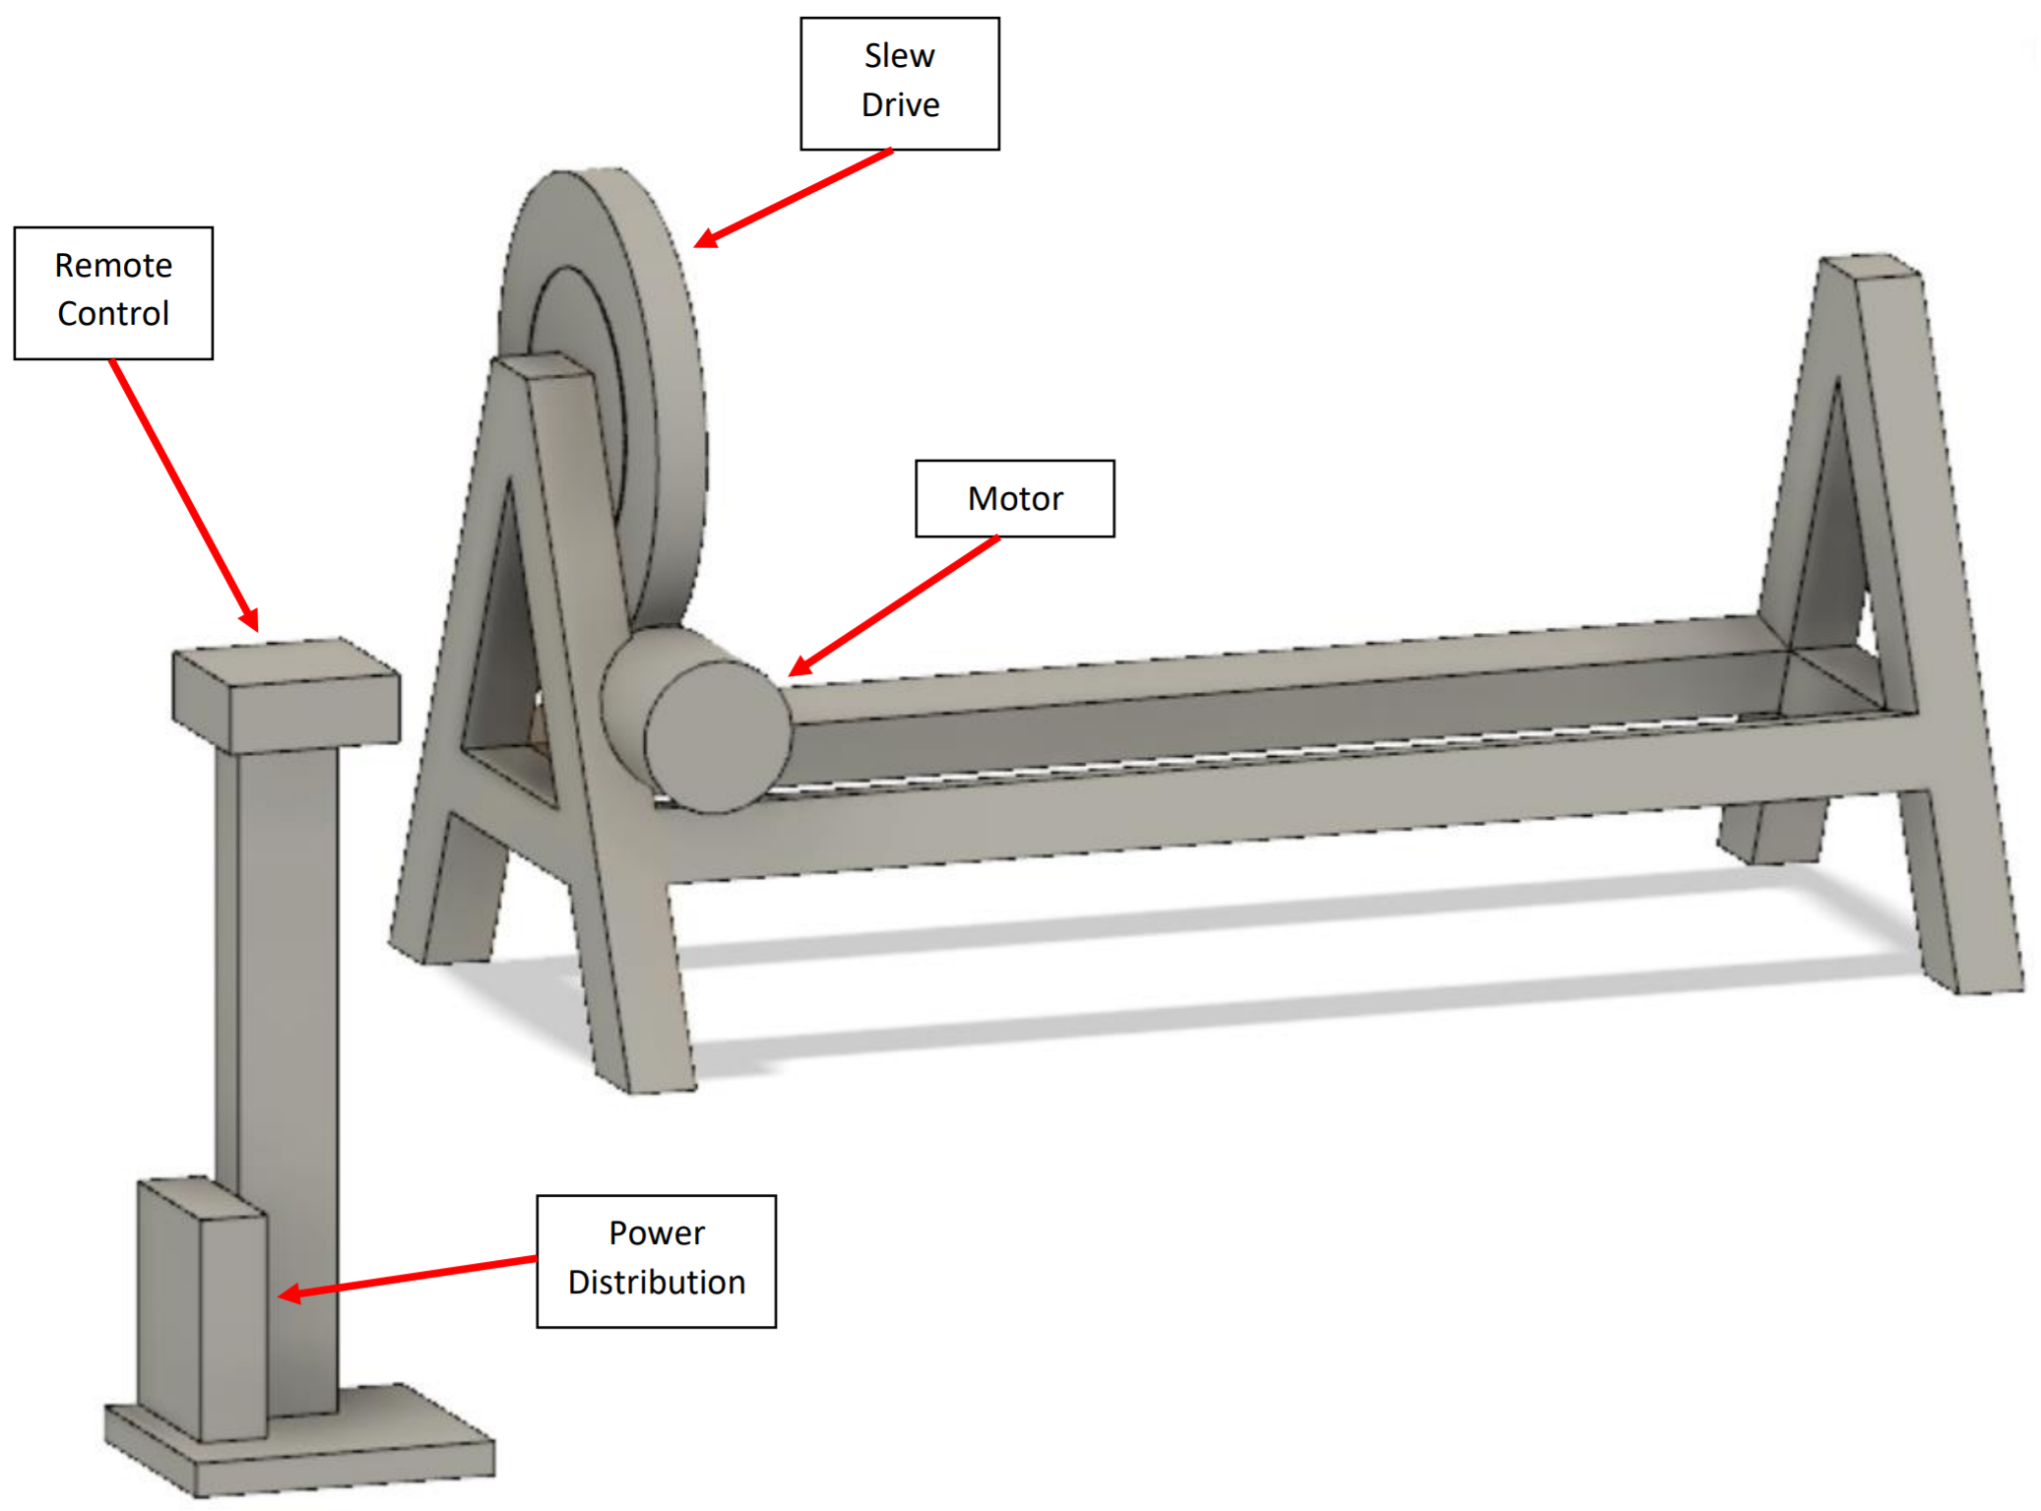

Figure 6‑2 - System Model

#### Power Distribution Panel

The disconnect box is a steel enclosure which passes the 230 VAC input voltage from the Doepker Industries facilities to the rotator subsystem, while also transforming the voltage to 12 VDC which can be used by the Control Panel to control the system. It houses the overload protection and main disconnect and contains an E-Stop relay used to prevent AC voltage from going to the Rotator subsystem if the emergency stop is activated. The subsystem is designed to be attached to the system “A” frame.

#### Control Panel

The Control Panel subsystem is a steel enclosure which contains the microcontroller as well as buttons for controlling the system. The Control Panel performs the computing operations in the overall system by taking user input from the buttons on the panel and driving the motor in the Rotator. The panel takes 12 VDC input from the Power Distribution Panel and Rotator for monitoring purposes, which is converted to 9 VDC for the microcontroller. It also outputs 12 VDC to both the Power Distribution Panel and Rotator, used to control parts of the system such as resetting the E-Stop and rotating operations. The panel is mounted onto a stand, which is connected to the system by a 10-foot long flexible cord.

#### Rotator

The Rotator consists of a motor, encoder, and a gear reducer. The motor used is a servo motor, which has a built-in encoder. The encoder provides closed loop feedback signals to provide speed/position information to the microcontroller in the Control Panel. The gear reducer is used to step down the motor’s speed of rotation, simultaneously increasing the torque to high enough levels to rotate and attached load. The output shaft of the gear reducer will interface with a welding table provided by the client. These components are mounted to the top of the “A” frame. The subsystem as a whole takes 230 VAC from the Power Distribution Panel and 12 VDC from the Control Panel for motor control. It outputs 12 VDC to the Control Panel for monitor and control.

## Detailed System Design

The purpose of this section is to discuss in detail the hardware design of the system. The design of the Control Panel and Rotator will be explored here.

### Control Panel

The Control Panel is a steel enclosure which contains the Arduino Uno microcontroller, motor driver, and buttons for system operation. It is connected to the system by a 10-foot flexible cable and is mounted onto a stand for easy access. The front of the enclosure may be opened for maintenance procedures, which may include reprogramming the microcontroller or replacing any components.

The panel takes 12 VDC input/output from the Power Distribution Panel and the Rotator subsystems. The power input from the Power Distribution Panel is used to power the microcontroller whilst the input from the Rotator is used by the microcontroller to monitor and control the rotating operations. The 12 VDC output of the Control Panel is used to control the E-Stop of the Power Distribution Panel and send signals to rotate the Rotator.

The Arduino Uno board is based on the ATmega328P microcontroller. It can perform all the computing required to operate the system using the onboard I/O pins. The pins are used to receive user input from the Power Distribution Panel and Rotator, and to drive the motor driver/E-Stop. It is programmed with the system software, which regulates the timing and duration of which the table will be rotated. Finally, the Arduino board sends a 12 VDC signal to the E-Stop Circuit to engage the E-stop relay. If an E-stop has been enabled in the system, it will then report to the user via the Control Panel’s LED.

The panel consists of an assortment of buttons to control the rotation of the system, described in Section 6.3.2. To operate the system, the operator must hold down a safety button which prevents unintended rotation. The panel also has an LED, turned on in unique combinations to provide the operator with information on the state of the system.

Finally, the Control Panel features an E-stop button to allow the operator to override the system operations and shut off power to the Rotator subsystem. The E-stop button will not shut off power to the microcontroller to prevent any damage from being caused by a sudden power removal.

### Rotator

The Rotator subsystem contains a motor, encoder, and gear reducer. It is mounted to the top of the “A” frame and enables the system to rotate the load. The subsystem takes 230 VAC from the Disconnect Box to power the motor and 12 VDC from the Control Panel to signal the direction and speed of the motor.

The motor used is an integrated servo motor from Teknic. It provides superior performance while allowing for simple integration with the microcontroller. The motor will be connected to a gear reducer with gear ratio of 500:1 to provide a torque of at least 1530 Nm. The output of the gear reducer is connected to the positioner table. Both the gear reducer and positioner table are to be provided by Doepker Industries.

### A Frames

The “A” frames which the system will be mounted onto are designed by Doepker Industries. The system is designed to be able to mount to the frames without the use of specialty tools.

### Technical Specifications

The system is designed to meet the following technical specifications listed in Table 6‑1:

|  |  |  |
| --- | --- | --- |
| Specification | Value | Comments |
| Static Torque | TBD | Break force unknown at time of writing. |
| Dynamic Torque | 2460 Nm |  |
| RPM | 0 – 5.2 RPM | Can be controlled to any RPM in this range. |
| Load Offset | TBD | Determined by attached table. |

Table 6‑1 - System Specifications

## System Operation

### System Software

The system’s software is run on the Arduino Uno microcontroller board. It is programmed in C++ into the board’s ATmega328 microcontroller and controls rotating operations. The board is a popular microcontroller and was selected for its reliability and ease of use.

The system’s rotating operations may only be activated from the Control Panel. It operates using states to determine what the system can do at a given time. A software state diagram is shown below in Figure 6‑3.



Figure 6‑3 - Software State Diagram

Each system state is described below:

* **Power State** – The system is powered off and no operations may be performed.
* **Standby State** – The default state of the system. The system is powered on, but no operations may be performed until the operator depresses the safety button.
* **Running State** – The system is enabled to perform all rotation operations. It will stay in this state if the safety button remains depressed or the E-stop is not activated.
* **E-Stop State** – The system is shifted to E-stop state when the E-stop button is activated. In the E-stop state, system operations cannot be performed until the E-stop button is deactivated and the system is reset.
* **Reset State** – The system shifts to the Reset state from the E-stop state when the E-stop is deactivated. The system is non-operational in this state and requires the operator to perform the reset operation to shift back into the Standby state, as explained in Section 6.3.2.2.

It is important to note that while the Standby and E-stop state perform the same function of preventing rotation operations, the Standby state applies a software lock to the motors while the E-stop state cuts power to the motor, applying a hardware lock on the system.

### System Operations

The system takes user input from the Control Panel. It also provides system status from the Control Panel.

#### User Inputs

Each form of user input is described below. See Figure 6‑4 for a mock-up of the Control Panel:

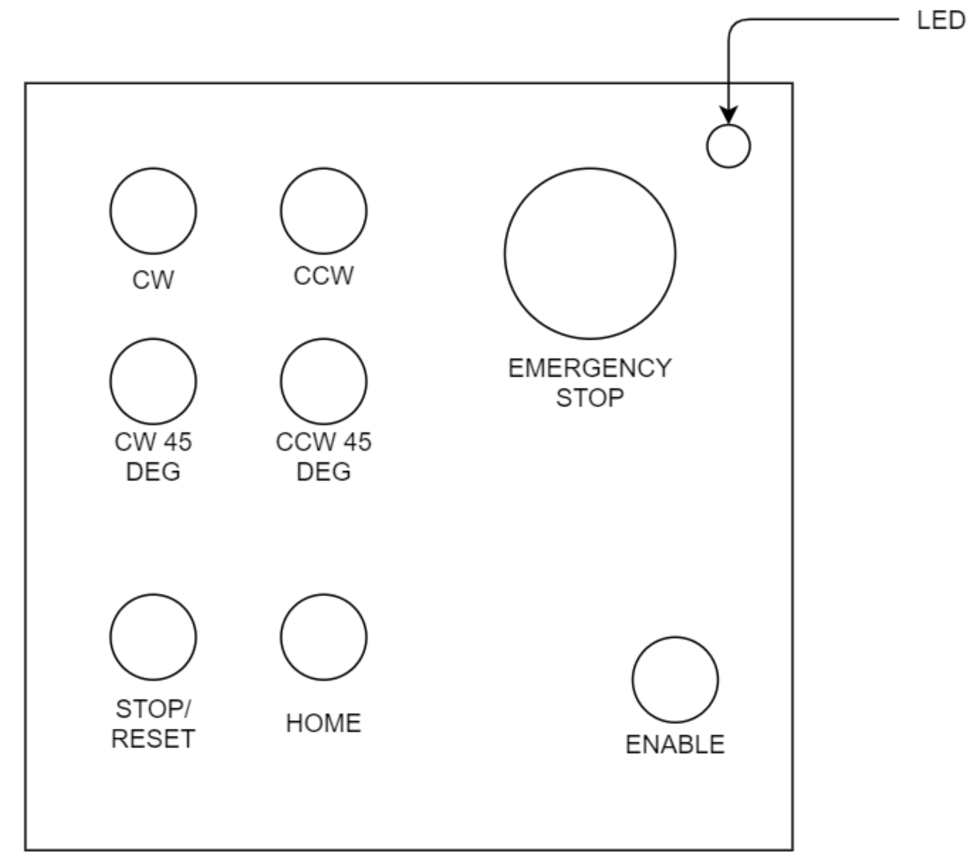

Figure 6‑4 - Control Panel Layout

**Control Panel:**

* **Rotate CW Button** – located on the front of the panel. Rotates the system 1° in the clockwise direction around the horizontal axis. Figure 6‑5 illustrates how the rotation direction is defined. The left side of the system is defined as the side which houses the Rotator subsystem, when oriented from the long lengthwise side.
* **Rotate CCW Button** – located on the front of the panel. Rotates the system 1° in the counterclockwise direction.
* **Rotate 45° CW Button** – located on the front of the panel. Rotates the system 45° in the clockwise direction.
* **Rotate 45° CCW Button** – located on the front of the panel. Rotates the system 45° in the counterclockwise direction.
* **Home Button** – located on the front of the panel. Rotates the system to the home angular position. Also used to set a new home position in the system, if held for more than 5 seconds.
* **Safety Button** – located on the front of the panel. The safety button must be depressed while performing rotating operations and shifts the system to the Running State.
* **Stop Button** – located on the front of the panel. Pressing the button stops the system from rotating during the running state. When in the E-stop state, pressing this button puts the system back into the Standby state.

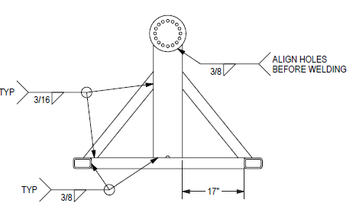

Figure 6‑5 - System Rotation Direction. Left-Side View of the System

#### Resetting the System

When put into the reset state, the system may return to the Standby mode through two different methods. The first method is to power cycle the system by turning it off and back on. It can also be transitioned back to the standby state by holding the safety button and pressing and releasing all four rotation buttons at once (CW, CW 45, CCW, and CCW 45). Once buttons are released, regular rotating operations may be resumed.

#### Operator Feedback

The system provides the operator with visual feedback using an LED, located on the front of the Control Panel. The LED is used to depict the current state that the system is in.

A description of the LED’s behaviour for each state is described below in Table 6‑2:

|  |  |
| --- | --- |
| State | LED Behaviour |
| Power | Off |
| Standby | Slow Blink Red |
| Running | Fast Blink Red |
| E-Stop | Solid Red |
| Reset Required | Fast Blink Red |

Table 6‑2 - Behaviour of LED for each System State

#### Home Function

The system features a home position function, which allows the operator to quickly recall a home angular position. The home position is stored on the microcontroller and updated each time the home button on the Control Panel is depressed for more than 5 seconds. The purpose of this function is to remove the need for the operator to carefully set the system to a commonly used angular position by allowing the operator to simply press a recall button on the control panel instead. The safety button must be depressed first to use this function.

### E-Stop Functionality

The E-stop of the system performs a category 0 stop as defined by the NFPA 79 standard (Rockwell Automation, 2012). When an E-stop is engaged from the Control Panel, the E-Stop Circuit immediately stops 230 VAC power from reaching the Rotator subsystem, stopping all rotation operations immediately. However, power is still supplied to the rest of the system which comprises the Control Panel. The E-Stop Circuit notifies the microcontroller that an E-stop is active, which then will notify the operator that an E-stop is on using the LED on the Control Panel (see Table 6‑2).

To reactivate the system after an E-stop, the E-stop button must first be disengaged. Once the Control Panel indicates that the system requires a reset (Table 6‑2), the operator may reset the system to allow for regular operations to be performed again (see Section 6.3.2.2).

# System Test Plan

## Verification Process

### Introduction

The overall objective of the verification process is to thoroughly examine all parts of the Doepker Industries Robotic Positioner at the software, hardware and system levels to verify their compliance with the system requirements. To this end, a comprehensive suite of tests is planned.

The verification program is characterized by a number of major features:

* Detailed tests are performed according to authorized test procedures.
* Test results are to be compared to the predetermined success criteria, which are derived from the appropriate specifications. These criteria are defined in the test procedures.
* Test results and test equipment information is recorded in the authorized test procedure.
* Analyses, inspections, and dry run specific tests are completed prior to FAT and are reviewed with the client.

Formal system-level acceptance tests will be performed at the University of Saskatchewan’s College of Engineering. The client will be requested to formally witness these tests and sign off the appropriate test procedure results once the tests are completed.

### Verification Methods

Verification methods are defined as follows:

* Analysis – Requirements are verified by applying indirect methods such as mathematical analysis, modeling, simulation, similarity assessments, review of design, and validation of records.
* Inspection – Requirements are verified by direct visual observation of passive characteristics, without the use of specialized equipment or services.
* Test – Requirements are verified by measurement of quantitative characteristics during or after the controlled application of stimuli under appropriately controlled conditions, or by direct visual observation of active qualitative characteristics.

### Verification Strategies

The assignment of verification methods is identified in the Robotic Positioner System Requirements Matrix.

* Verification by Analysis and Inspection. Verification by these methods will be completed prior to or during system integration testing. The verification results will be available for review.
* Verification by Test. This verification will be included in a completed test procedure. The test method will include demonstrations of functional requirements that are not meant to be exhaustive, but rather are meant to provide examples of typical operation as applicable to each system requirement

### Doepker Industries Notification

All acceptance tests will be scheduled in advance. Doepker Industries will be given 1 week notice of any acceptance tests to be performed. Doepker Industries may attend any test at their discretion. Doepker Industries will be requested to formally witness the acceptance tests and sign off the appropriate test procedure results once the tests are completed.

The acceptance test procedures will be written and submitted to Doepker Industries 2 weeks prior to the start of the testing. After completing the corrections or modifications requested by Doepker Industries, the approved test procedure becomes the controlling document for executing the acceptance tests.

## Levels of Testing

### Overall Test Process

The overall test process is illustrated in Figure 7‑1. This figure illustrates the major activities included in the process and the sequence in which they are to be performed.



Figure 7‑1 - System Testing Process

### System-Level Testing

#### System Integration and Testing

The system integration tests are designed to eliminate anomalies from the system and to demonstrate that the assembled system meets the performance specifications. To meet this objective the system testing sequence is to:

* Verify the software and hardware independently.
* Integrate the hardware, software, and test equipment and conduct integration tests on the integrated equipment.
* Perform verification tests in accordance to the FAT procedure document.

#### FAT

Factory Acceptance Testing will be performed at the College of Engineering at the University of Saskatchewan prior to shipment. The purpose of these tests is to verify that the system meets the operational specifications prior to shipping the system to site.

The FAT procedures to be performed are located in Section 7.3. Section 7.4 contains the formal test procedures for the Doepker Industries Robotic Positioner. During FAT, the system requirements will be reviewed with the client to examine how each requirement is verified.

#### FAT Acceptance Review

After the FAT has been completed, a review meeting will be held. The purpose of this meeting is to review the test results and discuss any anomalies identified during the tests.

#### FAT Results

The results of the FAT tests and the minutes of the Factory Acceptance Review meeting will be formalized in a Factory Acceptance Report. This report will be issued to Doepker Industries within 1 week of the completion of the tests. It will include a copy of the test results and a summary of the testing.

#### Site Installation

Once the system has arrived on site, testing will be performed to verify that no shipping damage has occurred. Once the installation checks have been successfully completed, the on-site acceptance testing will begin. A subset of the FAT procedure will be completed under client supervision. A meeting will be conducted to discuss any anomalies found during site testing, and an action plan to resolve all anomalies will be developed.

### Required Test Equipment

The equipment listed in Table 7‑1 will be required to perform system-level testing.

Table 7‑1 - Test Equipment

|  |  |  |  |
| --- | --- | --- | --- |
| **Item** | **Vendor** | **Description** | **Quantity** |
| TBD |  |  |  |
|  |  |  |  |
|  |  |  |  |

### Anomalies – Log Items

Each anomaly detected during testing that is significant enough to warrant tracking shall be documented and tracked as a log item. Each log item documents one anomaly and shows the date, the originator’s name, the test phase that the anomaly was detected in and the category of the anomaly. In addition, the log item provides a concise and complete description of the problem and a suggested course of action to clear the anomaly. A log item is removed once the anomaly has been corrected and the fix is verified. A Google spreadsheet will be used to track log items in real time. Doepker Industries will be provided a link to view the spreadsheet.

## Factory Acceptance Testing

### Introduction

The formal system test procedures describe the purpose of the test, the configuration of the test, step-by-step procedures for the test, and acceptance criteria. Section 7.4 contains the formal test procedures for the Doepker Industries Robotic Positioner.

Each test procedure is written and reviewed prior to use. Each test procedure is prepared to a standard format. This format contains the following sections:

1. Title Page. Identifies the test procedure, who conducted the test, who approved the test, and the date the test was performed.
2. Scope. Defines what the test procedure is to be used for and a general statement on the scope of the test.
3. Required Test Equipment. Provides a list of the test equipment required to perform the test. Space is provided within this table to identify the actual test equipment used during the test.
4. Detailed Test Procedure. Contains the step-by-step procedure for performing the test. Included is space for verification and recording of measurement results. Where applicable, pass/fail criteria are included in the procedure. System test procedures are developed based on the customer’s requirements.

## Doepker Industries Robotic Positioner Test Procedures

### Purpose

The purpose of this procedure is to verify that the performance and function of the Doepker Industries Robotic Positioner meets its requirements as specified in Robotic Positioner System Requirements Matrix.

### Test Failures

Minor problems encountered during testing shall be corrected and the test restarted from the last successful step. If major problems are encountered, each problem shall be recorded on a log item form, clearly indicating which test step has failed and what the configuration is so that the failure scenario can be recreated at a later time. The log item number shall be recorded in the procedure, next to the applicable test step for future reference.

### Test Preparation

#### Required Test Equipment

Fill in the information in Table 7‑2 for each piece of test equipment used for the system tests.

Table 7‑2 - Test Equipment

|  |  |  |  |
| --- | --- | --- | --- |
| **Description** | **Vendor** | **Model** | **Serial Number** |
| 500 kg load | TBD | TBD | TBD |
|  |  |  |  |
|  |  |  |  |

#### Test Setup

Figure 7‑2 shows the test setup. Configurations and settings that differ for each test are detailed in the test procedure.

| Step | Action | Verify |
| --- | --- | --- |
|  | Verify that the equipment is configured as per Figure 7‑2. Ensure that no load is attached to the table and the system is connected to a 230 VAC source. | ______ |

| Test Setup Results |
| --- |
| Comments: |
| Signoff:  Group #5 Representative Signature: ____________  Doepker Industries Representative Signature: ____________  Date: ____________ |

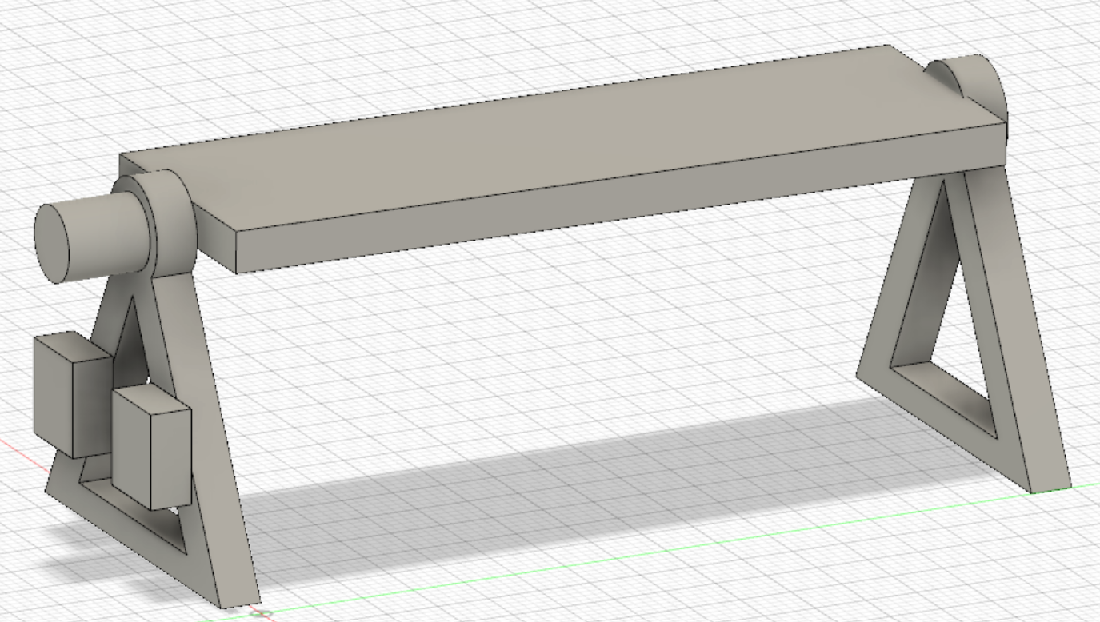

Figure 7‑2 - Test Setup

#### Requirements Verified by Inspection

The following review can be conducted any time during FAT. It is not a prerequisite to starting test.

| Step | Action | Verify |
| --- | --- | --- |
|  | Review the System Requirements Matrix to confirm that all those requirements to be verified by inspection have been verified. | ______ |

| System Inspection Results |
| --- |
| Comments: |
| Signoff:  Group #5 Representative Signature: ____________  Doepker Industries Representative Signature: ____________  Date: ____________ |

### Detailed Procedures

#### Test No. 1 – Load Testing

##### Objective

The objective of this test is to verify that the system meets the following rotation design requirements:

|  |  |
| --- | --- |
| **Requirement** | **Description** |
| RD-1 | The system shall continuously rotate a load 360° around the horizontal axis. |
| RD-3 | The system shall support at minimum 1177 newton-meter (N m) of dynamic torque. |
| RD-4 | The system shall support at minimum 941 N m of static torque. |
| RD-5 | The system shall support a load of maximum 500 kilograms (kg) weight. |
| RD-9 | The load shall remain fixed along the rotational axis when the system is not rotating. |
| HD-2 | The system shall remain stationary during operation. |

##### Configuration

Configure the test set-up as per Figure 7‑2 and ensure the following additional set-up is completed:

* The positioner table is set to an angle where a load may be attached parallel to the ground.
* There is no load attached to the positioner table.
* The system is turned on and in standby mode (status LED on operator panel is lit in an amber color and the buzzer is off).

##### Test Steps

| Step | Action | Verify |
| --- | --- | --- |
|  | Obtain a load that is around 500kg in mass. The load must be able to be attached securely to the positioner table without impeding rotation. Record the weight of the load below:  Load weight = ______ kg | ______ |
|  | Attach the load so that the center of mass is at the middle of the positioner table. | ______ |
|  | Calculate the static and dynamic torque from the weight and vertical center of mass of the load.  The vertical center of mass is measured from the center of mass of the load to the table surface.  Vertical Center of Mass = ______ m  Static Torque = Load Weight * Vertical Center of Mass = ______ Nm  Dynamic Torque = Power/Speed = ______ Nm | ______ |
|  | Depress and hold the safety button on the operator panel. Press and hold the “ROTATE CW” button until the load has completed approximately 2 revolutions. | ______ |
|  | Verify that the load is still attached securely to the table and has not shifted in position. | ______ |

| Load Testing Test Results |
| --- |
| Comments: |
| Signoff:  Group #5 Representative Signature: ____________  Doepker Industries Representative Signature: ____________  Date: ____________ |

#### Test No. 2 – Rotation Speed Testing

##### Objective

The objective of this test is to verify that the system meets the following rotation design requirements:

|  |  |
| --- | --- |
| **Requirement** | **Description** |
| RD-7 | The system shall rotate at a minimum speed of 1.0 rotations-per-minute (rpm). |
| RD-8 | The system shall rotate at a maximum speed of 5.0 rpm. |
| HD-2 | The system shall remain stationary during operation. |

##### Configuration

Configure the test set-up as per Figure 7‑2 and ensure the following additional set-up is completed:

* The load from Test No. 1 – Load Testing is attached to the positioner table.
* The system is turned on and in standby mode (status LED on operator panel is lit in an amber color).

##### Test Setup

Acquire a clock and a protractor for time and angle measurements. For the test:

* The exact time of the clock does not matter because a difference of time is measured.
* Angle measurements are taken with respect to the horizontal axis, with 0° being the rightmost point from the left-side view.

##### Test Steps

| Step | Action | Verify |
| --- | --- | --- |
|  | Record the current time and angle at which the positioner table is at. Immediately proceed to the following step.  Time1 (hh:mm:ss): ____________  Angle1: ______° | ______ |
|  | Depress and hold the safety button on the operator panel. Press and hold the “ROTATE CW” button until the load has completed at least 2 revolutions. | ______ |
|  | Record the time and angle at which the positioner table is at immediately after step 2.  Time2 (hh:mm:ss): ____________  Angle2: ______° | ______ |
|  | Calculate the rotations-per-minute using the following equation:  Delta_time = Time2 - Time1 = ______ seconds  Rotations-per-minute = (Angle2 - Angle1)/( Delta_time) = ______ rpm | ______ |
|  | Verify that the rotations-per-minute calculated in step 4 is between 1.0 and 5.0 rpm. | ______ |
|  | Verify that the system remained stationary during operation. | ______ |

| Rotation Speed Test Results |
| --- |
| Comments: |
| Signoff:  Group #5 Representative Signature: ____________  Doepker Industries Representative Signature: ____________  Date: ____________ |

#### Test No. 3 – E-Stop and Reset Testing

##### Objective

The objective of this test is to verify that the system meets the following rotation design requirements:

|  |  |
| --- | --- |
| **Requirement** | **Description** |
| SR-1 | The system shall have an easy-to-access emergency stop button, which stops all system operations when pressed. |
| SR-2 | The system shall have a switch to disable/enable rotation operations. |
| SR-3 | The system shall audibly alert the operator when rotating. |
| UIR-4 | The system’s operator panel shall indicate if the system is rotation locked. |
| UIR-5 | The system shall have an on/off button and indicator. |

##### Configuration

Configure the test set-up as per Figure 7‑2 and ensure the following additional set-up is completed:

* The system is turned off.

##### Test Steps

| Step | Action | Verify |
| --- | --- | --- |
|  | Turn the system on by pressing the “ON/OFF” button on the control box. Verify that the system enters standby mode (status LED on operator panel is lit in an amber color and the buzzer is off). | ______ |
|  | Depress and hold the safety button on the operator panel to put the system into running mode. Verify that the LED is blinking on/off in a green color. | ______ |
|  | Press and hold the “ROTATE CW” button. Verify that the table is rotating in the clockwise direction and the buzzer is beeping while the button is depressed. | ______ |
|  | Release the “ROTATE CW” button. Verify that the table stops rotating and the buzzer stops beeping. | ______ |
|  | Press the “ROTATE CCW 45” button. Verify that the table is rotating in the counter-clockwise direction and the buzzer is beeping during the rotation (2s on/off). | ______ |
|  | While the table is rotating from step 4, activate the E-Stop button on the operator panel. This is done by lifting and twisting the button. | ______ |
|  | Verify that the table immediately stops rotating and the system exhibits the following behaviour:   * Operator Panel LED is blinking in a red color * Operator Panel buzzer is beeping rapidly (0.5s on/off) | ______ |
|  | Release the E-Stop button on the operator panel. Verify that the system enters the reset state by checking that the LED shifts to a solid red color and the buzzer beeps in 1s intervals. | ______ |
|  | Depress the reset button on the operator panel and verify that the system enters the standby mode immediately (status LED on operator panel is lit in an amber color and the buzzer is off). | ______ |

| E-Stop and Reset Test Results |
| --- |
| Comments: |
| Signoff:  Group #5 Representative Signature: ____________  Doepker Industries Representative Signature: ____________  Date: ____________ |

#### Test No. 4 – System Recall Testing

##### Objective

The objective of this test is to verify that the system meets the following rotation design requirements:

|  |  |
| --- | --- |
| **Requirement** | **Description** |
| RD-2 | The system shall be able to recall and rotate to a pre-set angular position. |
| RD-10 | The system shall rotate to angle positions with a resolution of maximum 1°. |
| UIR-6 | The operator panel shall have buttons to rotate 45˚ clockwise and counterclockwise from the current position. |

##### Configuration

Configure the test set-up as per Figure 7‑2 and ensure the following additional set-up is completed:

* The system is turned on and in standby mode (status LED on operator panel is lit in an amber color and the buzzer is off).

##### Test Setup

Acquire a protractor for angle measurements. For the test:

* Angle measurements are taken with respect to the horizontal axis, with 0° being the rightmost point from the left-side view.

##### Test Steps

| Step | Action | Verify |
| --- | --- | --- |
|  | Record the current angle at which the positioner table is at.  Angle1: ______° (add 360° to this value if it is negative) | ______ |
|  | Depress and hold the safety button on the operator panel. Press the “ROTATE CCW 45” button. | ______ |
|  | Record the angle of the positioner table after the system finishes rotating in the counterclockwise direction.  Angle2: ______° (add 360° to this value if it is negative) | ______ |
|  | Verify that the system has rotated 45° in the counterclockwise direction by calculating the angular error. Verify that the angular error is within the passing criteria of +1°.  ΔAngle = Angle2 – Angle1 - 45°= ______° | ______ |
|  | Depress the “CALIBRATE” button on the control box to set the current position to be the “home” position. | ______ |
|  | Depress and hold the safety button on the operator panel. Press the “ROTATE CW 45” button. | ______ |
|  | Record the angle of the positioner table after the system finishes rotating in the clockwise direction.  Angle3: ______° (add 360° to this value if it is negative) | ______ |
|  | Depress and hold the safety button on the operator panel. Press the “HOME” button on the operator panel. | ______ |
|  | Verify that the system rotates the table back to the home position of Angle2. | ______ |
|  | Verify that the system has rotated 45° in the clockwise direction by calculating the angular error. Verify that the angular error is within the passing criteria of +1°.  ΔAngle = Angle3 – Angle2 + 45°= ______° | ______ |

| System Recall Test Results |
| --- |
| Comments: |
| Signoff:  Group #5 Representative Signature: ____________  Doepker Industries Representative Signature: ____________  Date: ____________ |

#### Test No. 5 – Unbalanced Load Test

##### Objective

The objective of this test is to verify that the system meets the following rotation design requirements:

|  |  |
| --- | --- |
| **Requirement** | **Description** |
| RD-6 | The system shall support a load offset of maximum 0.15 meters. |

##### Configuration

Configure the test set-up as per Figure 7‑2 and ensure the following additional set-up is completed:

* The positioner table is set to an angle where a load may be attached parallel to the ground.
* The system is turned on and in standby mode (status LED on operator panel is lit in an amber color and the buzzer is off).

##### Test Steps

| Step | Action | Verify |
| --- | --- | --- |
|  | Obtain a load that is around 500kg in mass. The load must be able to be attached securely to the positioner table without impeding rotation. Record the weight of the load below:  Load weight = ______ kg | ______ |
|  | Attach the load so that the center of mass is 0.15m from the middle of the positioner table. | ______ |
|  | Depress and hold the safety button on the operator panel. Press and hold the “ROTATE CCW” button until the load has completed approximately 2 revolutions. |  |
|  | Verify that the load is still attached securely to the table and has not shifted in position. | ______ |

| Unbalanced Load Test Results |
| --- |
| Comments: |
| Signoff:  Group #5 Representative Signature: ____________  Doepker Industries Representative Signature: ____________  Date: ____________ |

# Test Results

## Introduction

Due to the 2020 COVID-19 pandemic, system integration could not be completed before the end of the school term. Therefore, the system could only be partially verified to meet requirements and formal FAT procedures could not be performed. This section of the document will focus on describing what was tested to work and what could not be verified.

## System Integration Test Results

The system’s main functionality of rotating was partially verified. It was found that an operator is indeed able to control rotation operations on the system, however load tests were not able to be performed due to a lack of test equipment in the facility.

Additionally, the software of the system was independently verified using simulated hardware, which connected to the microprocessor and provided feedback in ways that the actual system is expected to provide.

It is presumed that the system shall integrate seamlessly once testing may be resumed at this point due to it being able to perform all software functions at the time of writing.

### Detailed Unit Test Results

Because the FAT procedure could not be performed, no formal test results exist for the system thus far. Only unit tests could be performed on individual parts of the system. However, listed below are the portions of the system to test as well as what functions as intended or not. A confidence level column is included to describe how likely the part is to meet requirements once system integration is resumed.

Table 8‑1 – Test Results

|  |  |  |
| --- | --- | --- |
| **System Part** | **Status and Comments** | **Confidence Level (Low, Medium, High)** |
| **Power Distribution Panel** | All parts have been tested with the rest of the system individually, but not with all integrated together. | High |
| **Remote Control** | It has been proven that the subsystem works as designed when interfaced with a hardware simulation of the Rotator subsystem. The only issue expected when integration resumes is calibrating the rotation operations with the Rotator (in terms of degrees to rotate).  Interfaces with the Power Distribution Panel properly. | Medium |
| **Rotator** | It has been proven that the rotator can respond to user input and rotate until being told to stop.  The rotator’s load specifications could not be tested due to a lack of time and equipment. However, it meets requirements for rotation speed (tested to rotate at 1 rotations-per-minute). | Medium |

### Non-Compliance Items

Shown below are the requirements that the system has been found to be non-compliant with reasons for non-compliance:

Table 8‑2 – Non-Compliance Items

|  |  |  |
| --- | --- | --- |
| **System Requirement** | | **Reason for Non-Compliance and Future Actions** |
| **SR-3** | The system shall audibly alert the operator when rotating. | It was discussed and agreed upon with the client that the proposed buzzer in the Control Panel would be too disruptive for operations in the Doepker Industries facility. |

### Future Testing

Once system integration is complete, the system must complete FAT testing as well as site installation. The team fully intends to complete the test process and fulfil the requirements agreed upon with the client.

# Economic Analysis

## Project Costing

### Prototype Costs

Small scale testing using the production microcontroller was conducted to start software development without waiting for component procurement. The prototyping costs are listed below in Table 9‑1 (tax not included):

Table 9‑1 - Cost of Prototyping

|  |  |  |  |
| --- | --- | --- | --- |
| **Item** | **Unit Price ($ CAD)** | **Quantity** | **Total ($ CAD)** |
| Arduino Uno R3 | 31.60 | 1 | **31.60** |

### Project Budget

It is estimated that 175 hours have been spent working on the project from the dates of September 20, 2019 to December 5, 2019. A rough breakdown of the hours spent during certain time periods is shown below:

Table 9‑2 - Project Billable Hours from September 20, 2019 to December 5, 2019

|  |  |  |  |  |
| --- | --- | --- | --- | --- |
| **Project Management Update #1 (09/20/19 – 10/17/19)** | **Project Management Update #2 (10/17/19 – 10/31/19)** | **Project Management Update #2 (10/31/19 – 11/21/19)** | **Remainder of Term**  **(11/12/19 – 12/05/19)** | **Total Hours** |
| 19.5 hours | 24 hours | 57 hours | 74.5 hours | **175 hours** |

It is estimated that an additional 125 hours have been spent working on the project from December 6, 2019 to April 7, 2020. A rough breakdown of the hours spent during certain time periods is shown below:

Table 9‑3 - Project Billable Hours from December 6, 2019 to April 7, 2020

|  |  |  |  |  |
| --- | --- | --- | --- | --- |
| **Project Management Update #4 (12/06/19 – 01/16/20)** | **Project Management Update #5 (01/17/19 – 02/06/20)** | **Project Management Update #6 (02/07/20 – 02/27/20)** | **Remainder of Term**  **(02/28/20 – 04/07/20)** | **Total Hours** |
| 13 hours | 29 hours | 33 hours | 50 hours | **125 hours** |

Based on the time spent working on the project, it is estimated that the total project cost so far is **$9,990.00**. This estimate was derived from the average engineering graduate salary of $64,922 (Insightrix Research Inc., 2019). The calculation of hourly wage was made with an assumption that the average engineer works 52 weeks/year and 37.5 hours/week. The hourly wage of each group member is therefore $33.30 an hour.

### System Bill of Materials

The bill of materials for one Robotic Positioner unit is displayed below in Table 9‑4. Taxes are not included.

Table 9‑4 - Bill of Materials

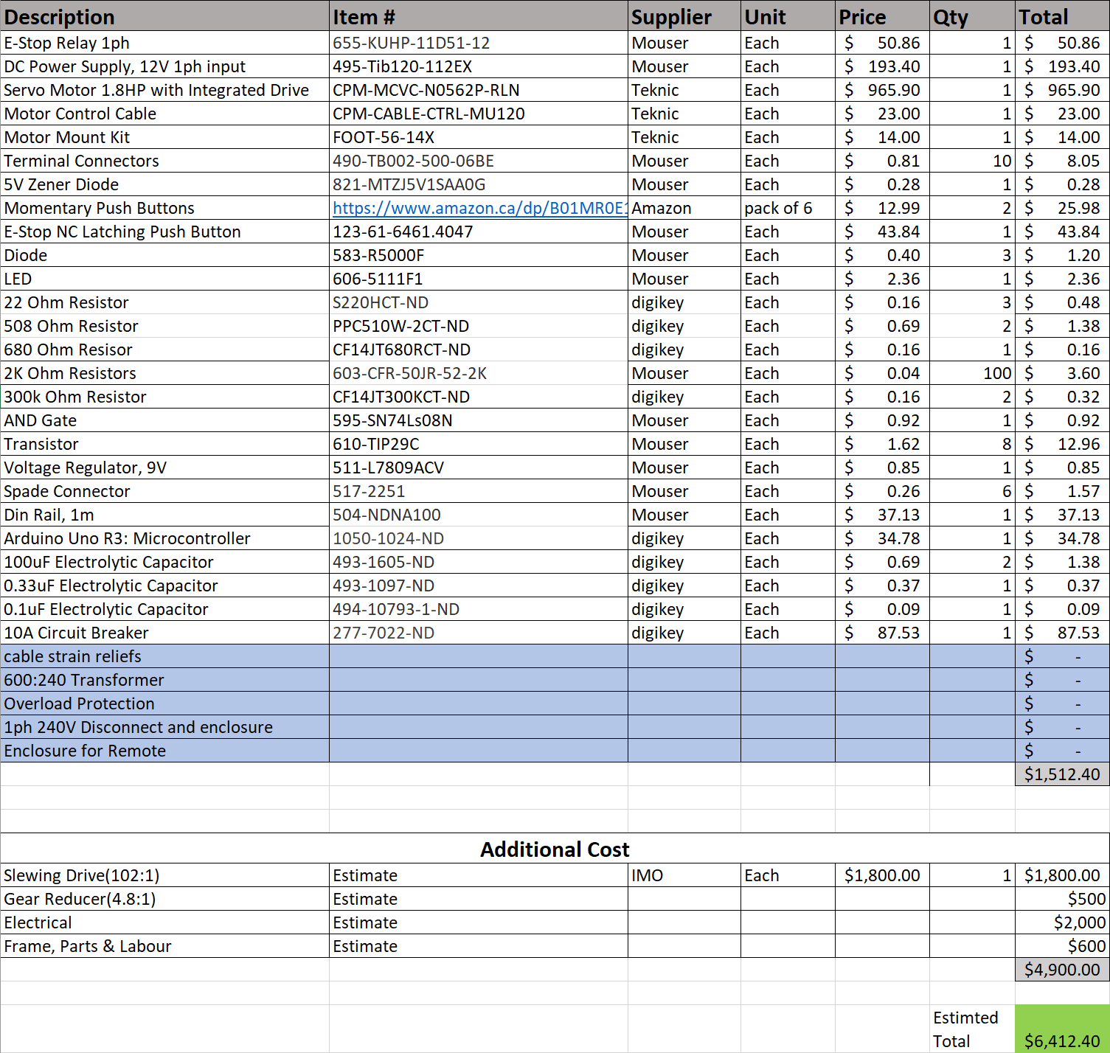

|  |  |
| --- | --- |
| Supplied by Totally Wired Electric |  |

## Design Unit Costing

If a full-scale production model is to be developed, an adequate and inexpensive source will need to be found for the servo motor and the slewing drive. An alternate servo motor and slewing drive may have to be found from another industrial-scale supplier for lower costs, which may end up changing the design.

Overall, the unit that would benefit the system costs by reducing prices would be the slewing drive. This could be done either by negotiating a lower wholesale cost with the supplier IMO or by finding a less costly alternative that provides similar performance. Changing the slewing drive would require the motor to be reselected as well in order to keep meeting system requirements. This may be a worthwhile venture if the current suppliers cannot provide better wholesale costs but will require more design work to work around the new components.

## Economic Feasibility

The overall concept behind the project was discussed with Doepker Industries. This is a niche system that is custom-built for Doepker, but it can be utilized in any industrial setting wherein heavy loads are required to be held at specific angles for the user to do work on.

Market analysis shows there is a demand for a lower cost robotic positioner in an industrial setting, however exact figures cannot be provided due to the need for more research into competitor products. So far, the solution designed for Doepker Industries undercuts the alternative systems in price, but other solutions may provide more features than ours. If this design is to be put on the market, its main selling advantage would be its low cost for basic functionalities. The price at which it is sold will depend on how much potential customers value the low price of our system and an exact price cannot be determined without more market surveying.

# Project Planning

## Introduction

This section is used to provide detailed schedule of the Doepker Industries Robotic Positioner system for the EE/CME 495 class for 2019-2020. The current project schedule is presented along with risks alleviated throughout the project. A work breakdown structure is included to show the amount of hours put into the project.

## Risks to Project Performance/Schedule

The project risks for this project have been reduced from those presented in CD2 – EE495/CME495 Robotic Positioner Project Plan. The following risks were alleviated:

* The risk of having long equipment lead times have been largely avoided by selecting components from vendors with shorter lead times. Components were ordered in December and came in January. There was a long lead time than expected to vendors having holiday shutdown.
* The risk of outsourcing production to Doepker Industries is gone as the system has now been designed and the design schematics have been provided for manufacturing.
* The risk of the system being operated in unexpected environments has been avoided by defining with the client what kind of environment the system shall be designed to operate in.
* Component reliability - there is a possibility that the components ordered will not be reliable due to being new products, or due to being specialty components which may not have been tested to the extent of a component meant for larger market. This was alleviated by ordering from companies that have a proven track record for delivering quality products, as recommended by Doepker Industries as well as from doing market research. The components received have not caused any issues as of yet.

## Milestones

Listed in Table 10‑1 are the major project milestones and their expected completion dates. The dates have been adjusted from the dates listed in CD2 – EE495/CME495 Robotic Positioner Project Plan to present more realistic milestone dates. Unfortunately, unit production and factory acceptance testing could not be completed in time and will not be indefinitely due to unforeseen circumstances. The user manual is behind schedule as well but is on track to be completed in early April 2020:

Table 10‑1 - Project Milestones

|  |  |  |
| --- | --- | --- |
| **Milestone** | **Date** | **Completed** |
| Begin Unit Production | December 26, 2019 | 90% |
| User Manual | January 26, 2019 | 70% |
| System Verification Plan | January 6, 2020 | 100% |
| Perform Factory Acceptance Testing | February 13, 2020 | 0% |
| Final Report | April 10, 2020 | 100% |

## Work Breakdown

Throughout the project, 369.5 hours were allocated to completing it. Of the 369.5, the group has only used 300 hours as of the time of writing. A table is attached below describing each group member’s allotted and used hours. All of the project management updates submitted throughout the project are attached in Appendix B.

Table 10‑2 – Group Time Allotment

|  |  |  |
| --- | --- | --- |
| **Group Member** | **Hours Allotted** | **Hours Consumed** |
| Jason Wong | 86 | 86 |
| Jordan Smith | 94.5 | 110 |
| Thomas Hu | 189 | 104 |

Jason completed the tasks required of him in the allotted time. He focused mainly on the software design and presentations, while contributing to documentation when asked.

Jordan ended up doing more work than originally planned. This was because he found that performing hardware design and testing was more time intensive than it was believed to be at the beginning of the project. In addition, extra time was spent building a simulator to simulate the Rotator when testing could not be performed directly with the Rotator due to the COVID-19 pandemic.

A surplus of hours was allotted to Thomas for the project that were not entirely used. This is partially due to Thomas being assigned much of the system design work in the work breakdown structure, but much of the work was shared amongst all three group members. In addition, much of the work was in the form of documentation, which was reduced due some redundancy amongst documents. For example, the interim report was a compilation of earlier documents and the final report was similarly the interim report with a few additions.

The primary reason why not all hours were used during the project is because the test process could not be completed. There is still 40 unused hours from the work breakdown structure that was dedicated towards performing acceptance tests. Some parts of the project ended up taking less time than expected, mainly the Final Project Report and the System Manual. Meanwhile, parts of the project that took more time than expected include the system integration process, which ended up being tricky at times.

The main issues that arose with the way the project schedule was drafted were that there were times when a major deliverable or task had to be completed but one of the group members may have been occupied with another course. This occurred near the end of term 1 for the interim report and throughout term 2 during the system integration period. This was worked around by having whoever was available contribute extra time and effort to ensure that the work still got done in time so that the schedule was not impacted too much. Unfortunately, system integration was heavily delayed during term 2 partially due to some items coming in late and partially due to all team members being busy with other coursework. These issues were brought up with the client whenever they came up to ensure that the client knew of any project delays, and it happened to benefit the group that the client was not in great demand for the system to be completed instantly.

## Work Breakdown Structure

Shown in Table 10‑3 on the following page is the overall work breakdown structure of the project, including the initial hours budgeted towards each task as well as the percentage of completion.

|  |  |  |  |  |  |  |
| --- | --- | --- | --- | --- | --- | --- |
| Table 10‑3 – Work Breakdown Structure | | | | | | |
| Task Number | **Task Name** | **Assignee** | **Hours Budgeted** | **Task Deadline** | **Task Completion** | **Predecessor** |
| 1 | **Create Problem Definition and Initial Project Plan** | Thomas | **10** | **Fri 10/1/19** | **100%** |  |
| 1.1 | Create Problem Definition | Jason | 5 | Wed 9/25/19 | 100% |  |
| 1.1.1 | Define Scope | Jason | 1 | Tue 9/24/19 | 100% |  |
| 1.1.2 | Define Objectives/Constraints | Jason | 2 | Wed 9/25/19 | 100% |  |
| 1.1.3 | Review Safety/Environmental Regulations | Jason | 2 | Wed 9/25/19 | 100% |  |
| 1.2 | Create Project Plan | Thomas | 5 | Fri 9/27/19 | 100% | 1.1 |
| 1.2.1 | Create Work Breakdown Structure | Thomas | 2 | Fri 9/27/19 | 100% |  |
| 1.2.2 | Create Gantt Chart | Thomas | 2 | Fri 9/27/19 | 100% |  |
| 1.2.3 | Perform Risk Analysis | Thomas | 1 | Fri 9/27/19 | 100% |  |
| 2 | **Sign and Return Non-Disclosure Agreement to Client** | Jordan | **1** | **Wed 9/25/19** | **100%** |  |
| 2.1 | Discuss Non-Disclosure Agreement with Supervisor | Jordan | 0.5 | Tue 9/24/19 | 100% |  |
| 3 | **Meet with Supervisor** | Jordan | **7** | **Mon 3/23/20** | **100%** |  |
| 4 | **Create Requirements Specification** | Thomas | **8** | **Fri 10/25/19** | **100%** |  |
| 4.1 | Review Requirements with Client | Jordan | 2 | Thu 10/24/19 | 100% |  |
| 5 | **Draft Detailed System Design Document** | Thomas | **30** | **Thu 12/5/19** | **100%** | 4 |
| 5.1 | Perform System Design | Thomas | **8** | **Fri 11/15/19** | 100% |  |
| 5.1.1 | Create Block Diagram | Thomas | 2 | Fri 11/15/19 | 100% |  |
| 5.2 | Perform Hardware Design | Jordan | **20** | **Fri 11/22/19** | 100% |  |
| 5.2.1 | Draft Design Schematics | Jordan | 10 | Fri 11/15/19 | 100% |  |
| 5.2.2 | Spec System Components | Jordan | 10 | Fri 11/22/19 | 100% |  |
| 6 | **Make/Perform Interim Project Presentation** | Jason | **20** | **Tue 11/26/19** | **100%** |  |
| 6.1 | Make Interim Project Presentation | Jason | 18 | Mon 11/25/19 | 100% |  |
| 6.2 | Present Interim Project Presentation | Jason | 2 | Tue 11/26/19 | 100% | 6.1 |
| 7 | **Write Interim Project Report** | Thomas | **20** | **Thu 12/5/19** | **100%** |  |
| 7.1 | Review Initial Project Plan | Thomas | 2 | Fri 11/22/19 | 100% |  |
| 8 | **Acquire System Components** | Jordan | **6** | **Mon 11/25/19** | **100%** | 5.2.2 |
| 9 | **Perform System Development** | Thomas | **60** | **Fri 1/10/20** | **90%** | 5 |
| 9.1 | Develop Software | Jason | 25 | Fri 12/27/19 | 100% |  |
| 9.2 | Build Hardware | Jordan | 20 | Fri 12/27/19 | 100% |  |
| 9.3 | Perform System Integration | Thomas | 15 | Fri 1/10/20 | 70% | 9.1, 9.2 |
| 10 | **Create System Verification Plan** | Thomas | **37.5** | **Mon 1/6/20** | **100%** | 4 |
| 10.1 | Define Use Cases | Thomas | 10 | Sun 12/22/19 | 100% |  |
| 10.2 | Define Test Cases | Thomas | 10 | Fri 12/27/19 | 100% | 10.1 |
| 10.3 | Write Test Procedures | Thomas | **15** | **Fri 1/3/20** | 100% | 10.2 |
| 10.3.1 | Review Test Procedures with Client | Jordan | 2.5 | Fri 1/3/20 | 100% |  |
| 11 | **Perform Acceptance Tests** | Thomas | **40** | **Thu 2/13/20** | **0%** | 10 |
| 11.1 | Perform Integration Testing | Jason | 20 | Tue 1/21/20 | 0% | 8, 9 |
| 11.2 | Review Integration Test Results with Customer | Jordan | 2.5 | Wed 1/22/20 | 0% | 11.1 |
| 11.3 | Perform Factory Acceptance Tests with Client | Thomas | 7.5 | Fri 1/31/20 | 0% | 11.2 |
| 11.4 | Write Factory Acceptance Report | Thomas | 10 | Fri 2/7/20 | 0% | 11.3 |
| 12 | **Write User Manual** | Thomas | **30** | **Thu 12/26/19** | **70%** | 5 |
| 13 | **Prepare Final Project Presentation and Demonstration** | Jason | **40** | **Fri 3/20/20** | **100%** | 5, 11 |
| 13.1 | Make Final Project Presentation | Jason | 20 | Tue 3/10/20 | 100% |  |
| 13.2 | Review Presentation with Client | Jordan | 1.5 | Wed 3/11/20 | 100% | 13.1 |
| 13.3 | Present Final Project Presentation | Jason | 1 | Fri 3/20/20 | 100% | 13.2 |
| 13.4 | Prepare Project Demonstration | Jordan | 15 | Thu 3/19/20 | 100% |  |
| 13.5 | Demonstrate Project | Jordan | 2.5 | Fri 3/20/20 | 100% | 13.3 |
| 14 | **Write Final Project Report** | Thomas | **60** | **Fri 4/10/20** | **100%** | 11 |
| 14.1 | Review Report with Client | Jordan | 2 | Tue 4/7/20 | 100% |  |

# Summary and Future Work

## Design Strengths and Weaknesses

It is presumed that the system shall meet most of its requirements and perform well. Unfortunately, this cannot be proved at the time of writing, but the outlook from testing suggest that it will perform as expected from this point on.

### Strengths

Strengths of the design chosen are that the system is that it is inexpensive to make, safe, and simple to use. This is said because as seen in the Bill of Materials, it costs under $6,500 to build a prototype unit. If production of the unit is desired, this price may likely lower due to wholesale pricing being available. Even so, the price undercuts the budget requirement of $10,000 per unit to build.

The system has been designed with safety in mind, and thus has features built in to ensure that the system is not unintentionally operated at any moment. Finally, the system is simple to use and theoretically should meet all the performance requirements of the client. It is not overly complex to maintain, and the safety features are implemented in an unobtrusive manner to the operator. Electrical welding positioners will be beneficial to Doepker Industries due to them being safer to operate. The design of the system should serve their purposes well.

### Weaknesses

Weaknesses of the design are that the system is that the Arduino UNO microcontroller ended up causing issues during the integration process by being difficult to debug. The board did not support debugging, which made it difficult to track down the source of bugs because printing log errors slowed down the overall program. This ended up being an issue because the counting of the motor encoder’s feedback pulses requires the Arduino to run at fast speeds, which made debugging difficult.

Another weakness is that the system utilizes single phase power. Switching to a three-phase design would use less phase current, meaning less heat produced. System integration so far has not identified this being an issue, but it will be something that needs to be monitored while testing under full loads. So far, the limiting factor from enabling three-phase usage is the E-stop relay and DC power supply are single phase. The motor itself is be able to harness the advantages of switching to over to three-phase power.

A minor weakness identified would be that cost savings could be found by using a 600VAC power source with an induction motor, variable frequency drive, and cooling system. More research will have to be done to source potential parts and design.

## Future Improvements

If another iteration of the design is to be made, the Arduino UNO microcontroller will be switched out in favor for an easier microcontroller to develop with. Another possibility would be to use a PLC, which would reduce the issues of timing experienced with the Arduino.

Three-phase power will likely be used as well, which will require redesign of the E-stop relay and a difference DC power supply source. This may increase the cost of production but will increase power efficiency. It remains to be seen if this will greatly benefit the design.

Lastly, if it is cost effective, a design using a difference source voltage of 600VAC will be considered. This would be a completely difference design in the Rotator subsystem and would likely need changes to code. If the cost-savings from new parts outweighs the development costs, this will be heavily considered in the next iteration.

# References

Insightrix Research Inc. (2019). *2019 Salary Survey.* Saskatoon: APEGS.

Rockwell Automation. (2012, June). Emergency Stop Push Buttons. Milwaukee, Wisconsin, USA.

# Appendix A – Technical Drawings

This section includes the technical drawings of the microcontroller pinout, motor control circuit, and operator panel circuit. These provide information on how the subsystems will interface with each other.

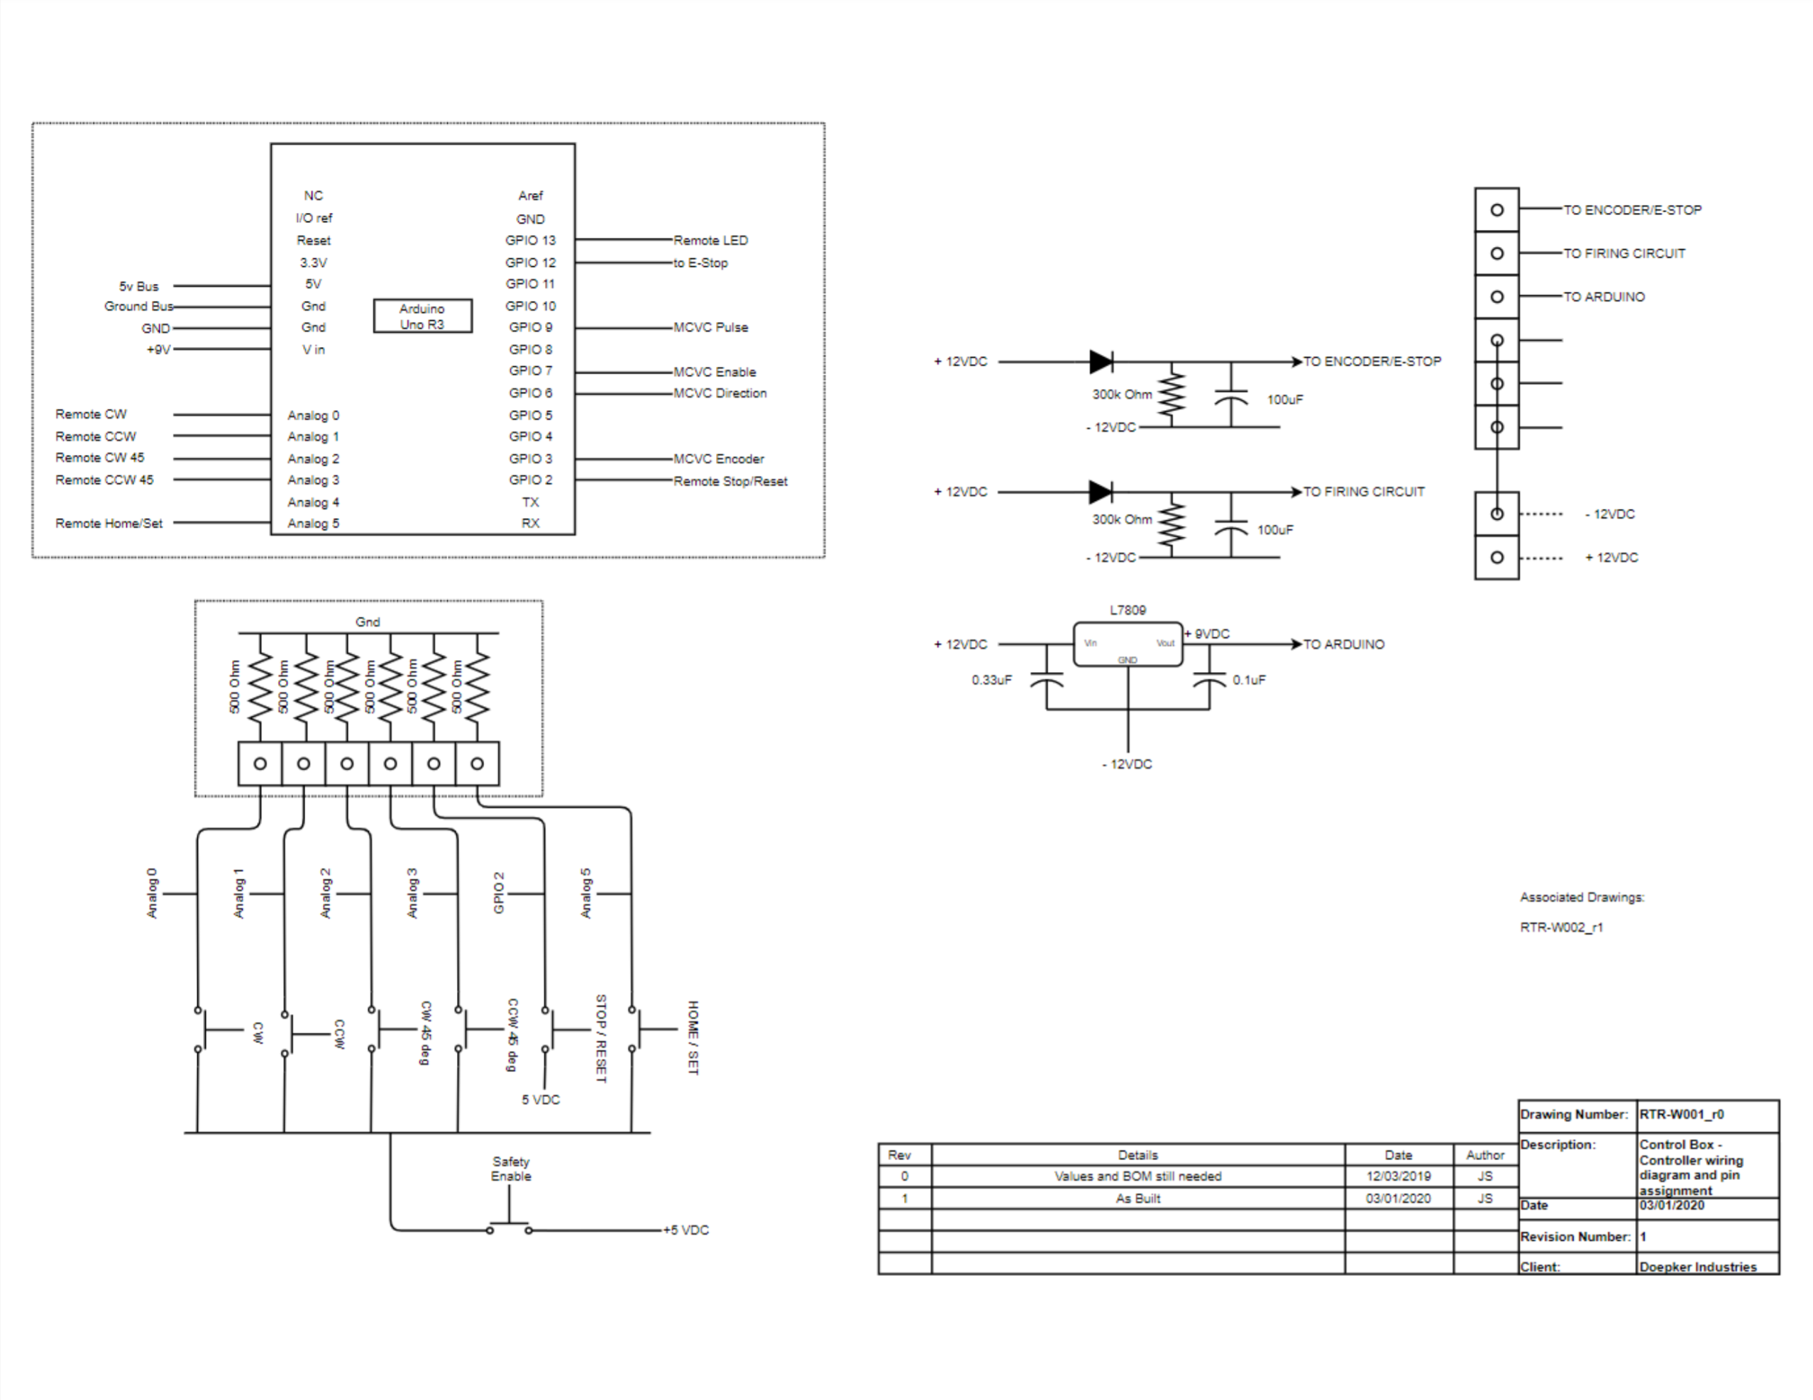

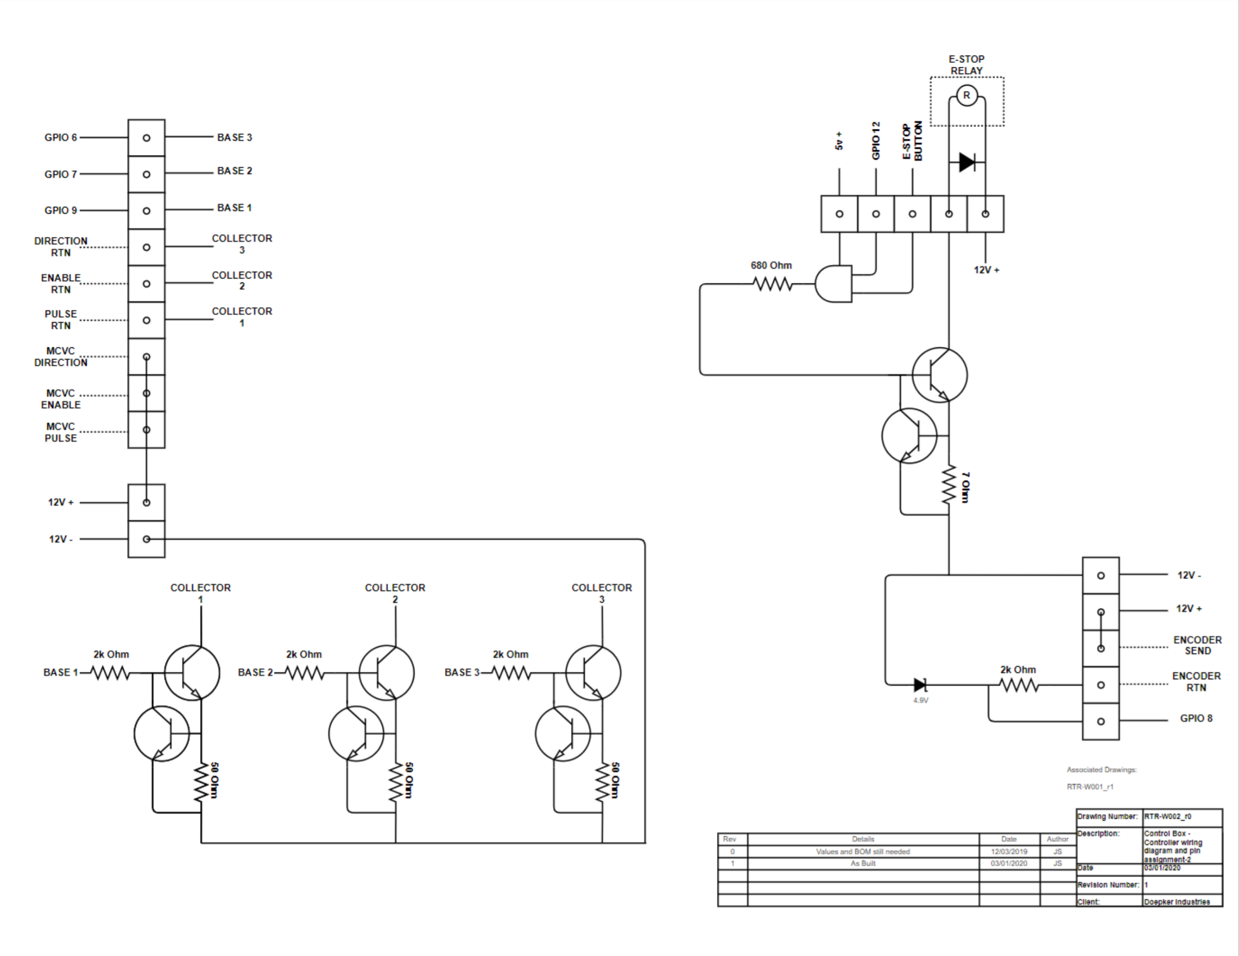

# Appendix B – Project Management Updates

This appendix contains all project management updates submitted throughout the course. They were compiled and used to aid in writing Section 10.

## Project Management Update 1

Dates Covered: September 20, 2019 to October 17, 2019

Part 1: Analysis of Task Progress

Shown below is the work completed by the group during the time period of September 20, 2019 to October 17, 2019.

The task numbers in the tables of this document correlate to the task numbers shown in the Work Breakdown Structure table found in revision 2 of CD2 – EE495/CME495 Project Plan.

|  |  |  |  |  |  |
| --- | --- | --- | --- | --- | --- |
| **Task** | **Initial Completion (%)** | **Planned Completion (%)** | **Actual Completion (%)** | **Planned Hours** | **Actual Hours** |
| 1.0 Create Problem Definition and Initial Project Plan | 0% | 100% | 100% | 10 | 13 |
| 1.1 Create Problem Definition | 0% | 100% | 100% | 5 | 6.5 |
| 1.2 Create Initial Project Plan | 0% | 100% | 100% | 5 | 6.5 |
| 2.0 Sign and Return Non-Disclosure Agreement to Client | 0% | 100% | 100% | 1 | 1 |
| 4.0 Create Requirements Specification | 0% | 50% | 50% | 2 | 2 |
| 5.2.2 Spec System Components | 0% | 50% | 25% | 5 | 6 |

Shown in the table below is the planned and actual number of hours spent by each team member.

|  |  |  |  |
| --- | --- | --- | --- |
| **Group Member** | **Planned Hours** | **Actual Hours** | **Main Tasks** |
| Jordan Smith | 5 | 9 | 2.0, 4.0, 5.2.2 |
| Jason Wong | 5 | 3 | 1.1 |
| Thomas Hu | 6 | 7.5 | 1.2, 3.0 |

Significant Deviations to the Project Plan are described below:

Jordan Smith made a lot of progress in determining which type of motor suits the client’s best needs. Unfortunately, the supplier is taking some time in responding about quotes. Jordan was able to make progress with the supplier by referring them to the client as contacts. Jordan realized the choice of a gearbox is necessary in lowering the rpm and increasing the torque from the motor to meet the client’s needs.

Jason Wong was working on researching the microcontroller for the rotational table. This task was straightforward in determining the correct microcontroller use for the time being. In case of any changes to the motor choice another microcontroller will be chosen.

Thomas Hu did not get the chance to do much work on creating the requirement specifications due to a heavy course load and because the group is still waiting for the client to provide hard requirements for the system.

More time was spent creating the problem definition and project plan than expected because extra hours weren’t budgeted towards proofreading and editing the documents. As such, 3 more hours were added to the completion time of the task.

Part 2: Future Task Planning

Shown below is the work that is planned to be completed by the group during the time period of October 17, 2019 to October 31, 2019.

|  |  |  |  |
| --- | --- | --- | --- |
| **Task** | **Initial Completion (%)** | **Planned Completion (%)** | **Planned Hours** |
| 4.0 Create Requirements Specification | 12.5% | 100% | 7 |
| 5.0 Draft Detailed System Design Document | 0% | 50% | 15 |
| 5.1 Perform System Design | 0% | 50% | 4 |
| 5.1.1 Create Block Diagram | 0% | 50% | 1 |
| 5.2 Perform Hardware Design | 0% | 50% | 10 |
| 5.2.1 Draft Design Schematics | 0% | 50% | 5 |
| 5.2.2 Spec System Components | 50% | 100% | 5 |
| 5.3 Research Code Design | 0% | 25% | 5 |
| 5.3.1 Design Source Code | 0% | 25% | 5 |

Shown in the table below is the planned number of hours to be spent by each team member.

|  |  |  |
| --- | --- | --- |
| **Group Member** | **Planned Hours** | **Main Tasks** |
| Jordan Smith | 20 | 5.2, 5.2.1, 5.2.2 |
| Jason Wong | 12 | 5.2.2, 5.3, 5.3.1 |
| Thomas Hu | 12 | 4.0, 5.1, 5.1.1 |

Part 3: Risk Mitigation

The largest risk associated with the project is the choice of a gearbox and motor. This will be a major component of the design for the project. The choice will determine how the rotational table will function. To combat this risk, we are contacting suppliers and researching the best possible course of action for the project.

Another major technical risk to the project is the time it takes for the supplier and client to respond to our questions. This poses a problem because it can potentially delay the progress of our project if we do not have enough information to proceed with our design and testing. We are trying to mitigate this risk by maintaining professional communication with the suppler/client and responding to emails as quick as possible.

Another problem is the initial position and recall position for the motor. This means our previous estimated time may be inaccurate and our future projections will be higher. To mitigate this risk, we are going to start researching ideas on how to code this problem. Jason Wong will research the idea of memory management for the positioning problems.

## Project Management Update 2

Dates Covered: October 18, 2019 to October 31, 2019

Part 1: Analysis of Task Progress

Shown below is the work completed by the group during the time period of October 18, 2019 to October 31, 2019.

The task numbers in the tables of this document correlate to the task numbers shown in the Work Breakdown Structure table found in revision 2 of CD2 – EE495/CME495 Project Plan.

|  |  |  |  |  |  |
| --- | --- | --- | --- | --- | --- |
| **Task** | **Initial Completion (%)** | **Planned Completion (%)** | **Actual Completion (%)** | **Planned Hours** | **Actual Hours** |
| 4.0 Create Requirements Specification | 12.5% | 100% | 100% | 7 | 7 |
| 5.0 Draft Detailed System Design Document | 0% | 50% | 0% | 15 | 0 |
| 5.1 Perform System Design | 0% | 50% | 0% | 4 | 0 |
| 5.1.1 Create Block Diagram | 0% | 50% | 0% | 1 | 0 |
| 5.2 Perform Hardware Design | 0% | 50% | 0% | 10 | 0 |
| 5.2.1 Draft Design Schematics | 0% | 50% | 25% | 5 | 1 |
| 5.2.2 Spec System Components | 50% | 100% | 100% | 5 | 2 |
| 5.3 Research Code Design | 0% | 25% | 25% | 5 | 3 |
| 5.3.1 Design Source Code | 0% | 25% | 10% | 5 | 1 |

Shown in the table below is the planned and actual number of hours spent by each team member.

|  |  |  |  |
| --- | --- | --- | --- |
| **Group Member** | **Planned Hours** | **Actual Hours** | **Main Tasks** |
| Jordan Smith | 20 | 12 | 5.2, 5.2.1, 5.2.2 |
| Jason Wong | 12 | 5 | 5.2.2, 5.3, 5.3.1 |
| Thomas Hu | 12 | 7 | 4.0, 5.1, 5.1.1 |

Significant Deviations to the Project Plan are described below:

Jordan Smith has made contact with IMO and is giving the requirements for gearing down the rotating table to an operable speed. Jordan is reviewing plans to use a 3-phase induction drive for this. In addition, Doepker has requested looking into reusing an existing gearbox they already have as an alternative design.

Jason Wong was working on researching the microcontroller for the rotational table and decided to go with an Arduino. In addition, Jason began to research how the motor would be coded for the Arduino. Some time was also spent on designing how the code should work for the motor.

Thomas Hu was not able to work on any of the system design because the requirements were not finalized yet before the end of the project management update period. This will be performed and completed in November.

Part 2: Future Task Planning

Shown below is the work that is planned to be completed by the group during the time period of November 1, 2019 to November 21, 2019.

|  |  |  |  |
| --- | --- | --- | --- |
| **Task** | **Initial Completion (%)** | **Planned Completion (%)** | **Planned Hours** |
| 5.0 Draft Detailed System Design Document | 0% | 75% | 22.5 |
| 5.1 Perform System Design | 0% | 100% | 8 |
| 5.1.1 Create Block Diagram | 0% | 100% | 2 |
| 5.2 Perform Hardware Design | 0% | 50% | 5 |
| 5.2.1 Draft Design Schematics | 25% | 50% | 7 |
| 5.2.2 Spec System Components | 50% | 100% | 4 |
| 5.3 Research Code Design | 25% | 40% | 3 |
| 5.3.1 Design Source Code | 10% | 25% | 2 |
| 6.0 Interim Project Presentation | 0% | 100% | 8 |
| 6.1 Interim Project Report | 0% | 80% | 15 |

Shown in the table below is the planned number of hours to be spent by each team member.

|  |  |  |
| --- | --- | --- |
| **Group Member** | **Planned Hours** | **Main Tasks** |
| Jordan Smith | 26.5 | 5.2, 5.2.1, 5.2.2, 6.0, 6.1 |
| Jason Wong | 25 | 5.2.2, 5.3, 5.3.1, 6.0, 6.1 |
| Thomas Hu | 25 | 4.0, 5.1, 5.1.1, 6.0, 6.1 |

Part 3: Risk Mitigation

A major technical risk to the project is the time it takes for the supplier and client to order the correct parts needed for this project. This poses a problem because it can potentially delay the progress of our project if we do not have all the parts to begin assembling and testing. We are trying to mitigate this risk by maintaining professional communication with the suppler/client and responding to emails as quick as possible.

The problem with the memory management for the initial position and recall position for the motor is still ongoing. This means our previous estimated time may be inaccurate and our future projections will be higher. To mitigate this risk, we are going to start researching and testing on a smaller motor on how to deal with this problem. Jason Wong will research the idea of memory management for the positioning problems.

## Project Management Update 3

Dates Covered: November 1, 2019 to November 21, 2019

Part 1: Analysis of Task Progress

Shown below is the work completed by the group during the time period of November 1, 2019 to November 21, 2019.

The task numbers in the tables of this document correlate to the task numbers shown in the Work Breakdown Structure table found in revision 2 of CD2 – EE495/CME495 Project Plan.

|  |  |  |  |  |  |
| --- | --- | --- | --- | --- | --- |
| **Task** | **Initial Completion (%)** | **Planned Completion (%)** | **Actual Completion (%)** | **Planned Hours** | **Actual Hours** |
| 5.0 Draft Detailed System Design Document | 0% | 50% | 50% | 22.5 | 20 |
| 5.1 Perform System Design | 0% | 50% | 50% | 8 | 8 |
| 5.1.1 Create Block Diagram | 0% | 50% | 50% | 2 | 1 |
| 5.2 Perform Hardware Design | 0% | 50% | 50% | 5 | 5 |
| 5.2.1 Draft Design Schematics | 25% | 50% | 50% | 7 | 2 |
| 5.2.2 Spec System Components | 50% | 100% | 75% | 4 | 6 |
| 5.3 Research Code Design | 25% | 25% | 25% | 3 | 1 |
| 5.3.1 Design Source Code | 10% | 25% | 25% | 2 | 2 |
| 6.0 Interim Project Presentation | 0% | 100% | 100% | 8 | 12 |
| 6.1 Interim Project Report | 0% | 80% | 50% | 15 | 10 |

Shown in the table below is the planned and actual number of hours spent by each team member.

|  |  |  |  |
| --- | --- | --- | --- |
| **Group Member** | **Planned Hours** | **Actual Hours** | **Main Tasks** |
| Jordan Smith | 26.5 | 18 | 5.2, 5.2.1, 5.2.2, 6.0, 6.1 |
| Jason Wong | 25 | 20 | 5.2.2, 5.3, 5.3.1, 6.0, 6.1 |
| Thomas Hu | 25 | 19 | 5.1, 5.1.1, 6.0, 6.1 |

Significant Deviations to the Project Plan are described below:

Jordan Smith has drafted a schematic for the hardware component of this design. Components have been found that meet specifications and a BOM has been submitted to the client for approval. Finding components for the design took considerably longer than expected and some final decisions need to be approved from the client before moving forward.

Jason Wong has ordered an Arduino Uno R3 for this project. In addition, the presentation PowerPoint has been completed and the team will conduct meetings for interim report.

Thomas Hu has been working on the detailed system design document and interim report. These reports experienced a slight delay from waiting on a final system design to be finalized.

Part 2: Future Task Planning

Shown below is the work that is planned to be completed by the group during the time period of November 22, 2019 to December 5, 2019.

|  |  |  |  |
| --- | --- | --- | --- |
| **Task** | **Initial Completion (%)** | **Planned Completion (%)** | **Planned Hours** |
| 5.0 Draft Detailed System Design Document | 50% | 100% | 10 |
| 5.2 Perform Hardware Design | 50% | 100% | 5 |
| 5.2.1 Draft Design Schematics | 50% | 100% | 5 |
| 5.3 Research Code Design | 40% | 50% | 3 |
| 5.3.1 Design Source Code | 25% | 50% | 4 |
| 6.1 Interim Project Report | 50% | 100% | 5 |
| 6.2 Interim Presentation | 90% | 100% | 5 |

Shown in the table below is the planned number of hours to be spent by each team member.

|  |  |  |
| --- | --- | --- |
| **Group Member** | **Planned Hours** | **Main Tasks** |
| Jordan Smith | 14 | 5.2, 5.2.1, 6.1 |
| Jason Wong | 15 | 5.3.1, 6.1 |
| Thomas Hu | 15 | 5.0, 6.1 |

Part 3: Risk Mitigation

A major technical risk to the project is the time it takes for the supplier and client to order the correct parts needed for this project. This poses a problem because it can potentially delay the progress of our project if we do not have all the parts to begin assembling and testing. We are trying to mitigate this risk by maintaining professional communication with the suppler/client and responding to emails as quick as possible.

The project going forward at this time will possibly have some set backs due to final exams and end of term. To mitigate this risk, we are going to work on the project over the holidays.

## Project Management Update 4

Dates Covered: December 6, 2019 to January 16, 2020

Part 1: Analysis of Task Progress

Shown below is the work completed by the group during the time period of December 6, 2019 to January 15, 2020.

The task numbers in the tables of this document correlate to the task numbers shown in the Work Breakdown Structure table found in revision 2 of CD2 – EE495/CME495 Project Plan.

|  |  |  |  |  |  |
| --- | --- | --- | --- | --- | --- |
| **Task** | **Initial Completion (%)** | **Planned Completion (%)** | **Actual Completion (%)** | **Planned Hours** | **Actual Hours** |
| 5.2 Perform Hardware Design | 50% | 100% | 75% | 5 | 6 |
| 5.2.1 Draft Design Schematics | 50% | 100% | 75% | 5 | 3 |
| 5.3 Research Code Design | 40% | 50% | 40% | 3 | 2 |
| 5.3.1 Design Source Code | 25% | 50% | 30% | 4 | 2 |

Shown in the table below is the planned and actual number of hours spent by each team member.

|  |  |  |  |
| --- | --- | --- | --- |
| **Group Member** | **Planned Hours** | **Actual Hours** | **Main Tasks** |
| Jordan Smith | 10 | 9 | 5.2, 5.2.1 |
| Jason Wong | 10 | 2 | 5.3, 5.3.1 |
| Thomas Hu | 10 | 2 | 5.2, 5.2.1, 5.3, 5.3.1 |

Significant Deviations to the Project Plan are described below:

Jordan Smith has made some alterations to the design, correcting some oversights and adding robustness to some of the sections. The full system will be tested once each section’s operation has been verified.

Jason Wong has begun coding the rotational functions for the project and will continue to research and test out the parameters for the recall position.

Thomas Hu will assist Jordan and Jason in their research and design on building circuit and coding for the system.

Part 2: Future Task Planning

Shown below is the work that is planned to be completed by the group during the time period of January 17, 2020 to February 5, 2020.

|  |  |  |  |
| --- | --- | --- | --- |
| **Task** | **Initial Completion (%)** | **Planned Completion (%)** | **Planned Hours** |
| 5.2 Perform Hardware Design | 75% | 100% | 5 |
| 5.2.1 Draft Design Schematics | 75% | 100% | 5 |
| 5.3 Research Code Design | 40% | 50% | 10 |
| 5.3.1 Design Source Code | 25% | 50% | 10 |
| 7.0 E-stop Circuit Build and Test | 0% | 100% | 5 |
| 7.0.1 Signal Firing Circuit Build and Test | 0% | 100% | 5 |
| 7.0.2 Encoder Return Circuit Build and Test | 0% | 100% | 5 |
| 7.0.3 Button Control Build and Test | 0% | 100% | 5 |
| 7.0.4 LED/Sound Indicator Circuit | 0% | 100% | 5 |

Shown in the table below is the planned number of hours to be spent by each team member.

|  |  |  |
| --- | --- | --- |
| **Group Member** | **Planned Hours** | **Main Tasks** |
| Jordan Smith | 30 | 5.2, 5.2.1, 7.0, 7.0.1, 7.0.2, 7.0.3, 7.0.4 |
| Jason Wong | 20 | 5.3, 5.3.1 |
| Thomas Hu | 20 | 5.2, 5.2.1, 5.3, 5.3.1 |

Part 3: Risk Mitigation

A major technical risk to the project is the time it takes for the supplier and client to order the correct parts needed for this project. This poses a problem because it can potentially delay the progress of our project if we do not have all the parts to begin assembling and testing. We are trying to mitigate this risk by maintaining professional communication with the supplier/client and responding to emails as quick as possible.

The project going forward at this time will possibly have some set backs due to other classes and exams. To mitigate this risk, we are going to work on the project weekly and communicate as much as possible.

## Project Management Update 5

Dates Covered: January 17, 2020 to February 6, 2020

Part 1: Analysis of Task Progress

Shown below is the work completed by the group during the time period of January 17, 2020 to February 6, 2020.

The task numbers in the tables of this document correlate to the task numbers shown in the Work Breakdown Structure table found in revision 2 of CD2 – EE495/CME495 Project Plan.

|  |  |  |  |  |  |
| --- | --- | --- | --- | --- | --- |
| **Task** | **Initial Completion (%)** | **Planned Completion (%)** | **Actual Completion (%)** | **Planned Hours** | **Actual Hours** |
| 5.2 Perform Hardware Design | 75% | 100% | 100% | 5 | 3 |
| 5.2.1 Draft Design Schematics | 75% | 100% | 100% | 5 | 6 |
| 5.3 Research Code Design | 40% | 50% | 70% | 10 | 10 |
| 5.3.1 Design Source Code | 30% | 60% | 50% | 10 | 5 |
| 7.0.0 E-stop Circuit Build and Test | 50% | 100% | 50% | 5 | 2 |
| 7.0.1 Signal Firing Circuit Build and Test | 50% | 100% | 50% | 5 | 2 |
| 7.0.2 Encoder Return Circuit Build and Test | 50% | 100% | 50% | 5 | 3 |
| 7.0.3 Button Control Build and Test | 50% | 100% | 50% | 5 | 2 |
| 7.0.4 LED/Sound Indicator Circuit | 0% | 100% | 0% | 5 | 0 |

Shown in the table below is the planned and actual number of hours spent by each team member.

|  |  |  |  |
| --- | --- | --- | --- |
| **Group Member** | **Planned Hours** | **Actual Hours** | **Main Tasks** |
| Jordan Smith | 30 | 14 | 5.2, 5.2.1, 7.0, 7.0.1, 7.0.2, 7.0.3, 7.0.4 |
| Jason Wong | 20 | 15 | 5.3, 5.3.1 |
| Thomas Hu | 20 | 0 | 5.2, 5.2.1, 5.3, 5.3.1 |

Significant Deviations to the Project Plan are described below:

Jordan Smith has not been able to free up the time to finish the tasks as planned. A considerable amount of his focus was put on arranging getting the physical rotator delivered and set up in the Hardy Lab, as well as motor setup and parts receiving.

Jason Wong has begun coding the rotational functions for the project and will continue to research and test out the parameters for the recall position. As for the testing portion, it will begin once the assembly of the unit is close to completion.

Thomas Hu was occupied with extracurricular work and DSP and was unable to find the time to work on reporting

Part 2: Future Task Planning

Shown below is the work that is planned to be completed by the group during the time period of February 6, 2020 to February 27, 2020.

|  |  |  |  |
| --- | --- | --- | --- |
| **Task** | **Initial Completion (%)** | **Planned Completion (%)** | **Planned Hours** |
| 5.3 Research Code Design | 70% | 100% | 10 |
| 5.3.1 Design Source Code | 50% | 100% | 10 |
| 7.0 E-stop Circuit Build and Test | 50% | 100% | 3 |
| 7.0.1 Signal Firing Circuit Build and Test | 50% | 100% | 3 |
| 7.0.2 Encoder Return Circuit Build and Test | 50% | 100% | 3 |
| 7.0.3 Button Control Build and Test | 50% | 100% | 3 |
| 7.0.4 LED/Sound Indicator Circuit | 0% | 100% | 5 |
| 8.0 Final Presentation | 0% | 25% | 10 |
| 8.1 Final Report | 0% | 25% | 5 |

Shown in the table below is the planned number of hours to be spent by each team member.

|  |  |  |
| --- | --- | --- |
| **Group Member** | **Planned Hours** | **Main Tasks** |
| Jordan Smith | 17 | 7.0, 7.0.1, 7.0.2, 7.0.3, 7.0.4 |
| Jason Wong | 20 | 5.3, 5.3.1, 8.0 |
| Thomas Hu | 20 | 5.3, 5.3.1, 8.1 |

## Project Management Update 6

Dates Covered: February 7, 2020 to February 27, 2020

Part 1: Analysis of Task Progress

Shown below is the work completed by the group during the time period of February 7, 2020 to February 27, 2020.

The task numbers in the tables of this document correlate to the task numbers shown in the Work Breakdown Structure table found in revision 2 of CD2 – EE495/CME495 Project Plan.

|  |  |  |  |  |  |
| --- | --- | --- | --- | --- | --- |
| **Task** | **Initial Completion (%)** | **Planned Completion (%)** | **Actual Completion (%)** | **Planned Hours** | **Actual Hours** |
| 5.3 Research Code Design | 75% | 100% | 100% | 10 | 5 |
| 5.3.1 Design Source Code | 50% | 100% | 80% | 10 | 5 |
| 7.0.0 E-stop Circuit Build and Test | 50% | 100% | 80% | 3 | 2 |
| 7.0.1 Signal Firing Circuit Build and Test | 50% | 100% | 80% | 3 | 4 |
| 7.0.2 Encoder Return Circuit Build and Test | 50% | 100% | 80% | 3 | 1 |
| 7.0.3 Button Control Build and Test | 50% | 100% | 80% | 3 | 2 |
| 7.0.4 LED/Sound Indicator Circuit | 0% | 100% | 50% | 5 | 1 |
| 8.0 Final Presentation | 0% | 25% | 10% | 10 | 3 |
| 8.1 Final Report | 0% | 25% | 25% | 5 | 5 |

Shown in the table below is the planned and actual number of hours spent by each team member.

|  |  |  |  |
| --- | --- | --- | --- |
| **Group Member** | **Planned Hours** | **Actual Hours** | **Main Tasks** |
| Jordan Smith | 17 | 15 | 7.0, 7.0.1, 7.0.2, 7.0.3, 7.0.4 |
| Jason Wong | 20 | 13 | 5.3, 5.3.1, 8.0 |
| Thomas Hu | 20 | 5 | 5.3, 5.3.1, 8.1 |

Significant Deviations to the Project Plan are described below:

Jordan Smith has prototyped and tested all circuits. Final board construction is taking longer than expected. Additional hours had to be spent on panel fabrication, adding terminal block connectors and procuring additional parts.

Jason Wong has begun coding the rotational functions for the project and will continue to research and test out the parameters for the recall position. As for the testing portion, it will begin once the assembly of the unit is close to completion.

Thomas Hu has began working on the final report. Time has been spent on correcting feedback from the interim report.

Part 2: Future Task Planning

Shown below is the work that is planned to be completed by the group during the time period of February 27, 2020 to March 16, 2020.

|  |  |  |  |
| --- | --- | --- | --- |
| **Task** | **Initial Completion (%)** | **Planned Completion (%)** | **Planned Hours** |
| 5.3 Research Code Design | 70% | 100% | 10 |
| 5.3.1 Design Source Code | 50% | 100% | 10 |
| 7.0 E-stop Circuit Build and Test | 80% | 100% | 2 |
| 7.0.1 Signal Firing Circuit Build and Test | 80% | 100% | 2 |
| 7.0.2 Encoder Return Circuit Build and Test | 80% | 100% | 2 |
| 7.0.3 Button Control Build and Test | 80% | 100% | 3 |
| 7.0.4 LED/Sound Indicator Circuit | 50% | 100% | 2 |
| 8.0 Final Presentation | 0% | 25% | 10 |
| 8.1 Final Report | 0% | 25% | 5 |

Shown in the table below is the planned number of hours to be spent by each team member.

|  |  |  |
| --- | --- | --- |
| **Group Member** | **Planned Hours** | **Main Tasks** |
| Jordan Smith | 13 | 7.0, 7.0.1, 7.0.2, 7.0.3, 7.0.4, 8.0 |
| Jason Wong | 20 | 5.3, 5.3.1, 8.0 |
| Thomas Hu | 20 | 5.3, 5.3.1, 8.1 |